FINAL REPORT

On

Expedia Recommendation Challenge



Team 8

Akash Bhatia

Hari Panjwani

Tarun Keswani

CONTENTS

* Problem Statement
* Data Description
* Data Preprocessing
* Data Visualization
* Approach to problem
* Tools
* Hadoop Installation
* Sentiment Analysis – Standford NLP
* Apache Hive
* Predicting Hotel Cluster – Random Forest
* Predicted Ranking Search - XGBoost
* Apache Spark
* Apache Kafka
* Obstacles & Resolution
* Future Scope
* Result
* References

Problem Statement

Expedia can be used to book airline tickets, hotel reservations, car rentals, cruises, vacation packages and various attractions and services via the internet or telephone agents. We have downloaded the dataset from the Kaggle. Expedia has provided logs of customer behavior. This data includes hotel clusters based on historical price, customer star ratings, geographical locations relative to city center, etc. They are interested in predicting which hotel group a user is going to book and to predict the order in which the search result should be shown to the users. Our goal is to predict the order of the search results and the booking outcome for a search.

End User

Our model can be used by any travel company like Expedia, Trip Advisor to understand travel patterns of their customers. They can use it to expand their customer base and market their products and packages based on the results of pattern analysis.

Application use case

* Predict if the search is going to result in a booking. And if so, which cluster will the booked hotel belong to.
* Hotel recommendation for a particular search criteria for the US.
* Study the travel patterns of users of the website.
* Analyze the locations preferred by tourists based on various factors like season, time, vacation.

DATA DESCRIPTION

We have downloaded data from Kaggle website which includes, shopping and purchase data as well as information on price competitiveness. The data are organized around a set of “search result impressions”, or the ordered list of hotels that the user sees after they search for a hotel on the Expedia website. In addition to impressions from the existing algorithm, the data contain impressions where the hotels were randomly sorted, to avoid the position bias of the existing algorithm. The user response is provided as a click on a hotel or/and a purchase of a hotel room.

Appended to impressions are the following:

a. Hotel characteristics

b. Location attractiveness of hotels

c. User’s aggregate purchase history

d. Competitive OTA information

The dataset, is split into a training and a test set (train.csv and test.csv respectively, each containing approximately 5 million records). Essentially, the dataset contains information about a search query of a user for a hotel, the hotel properties that resulted and for the training set, whether the user clicked on the hotel and booked it. More in specific, the following fields are present:

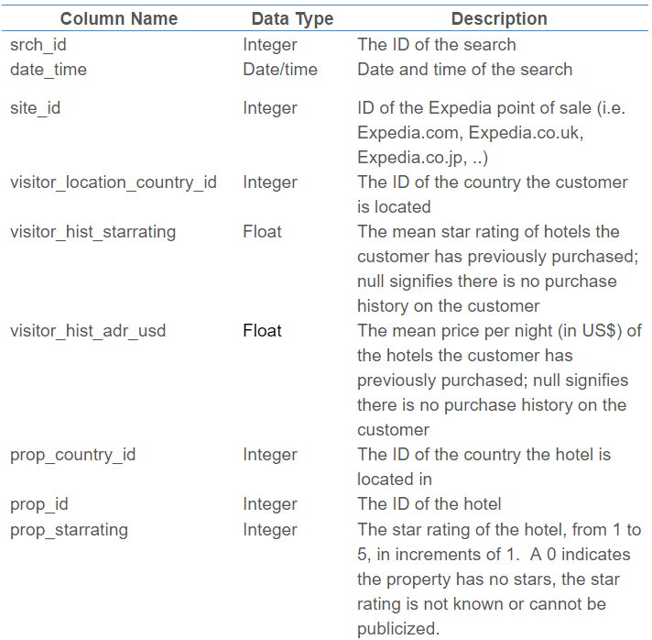

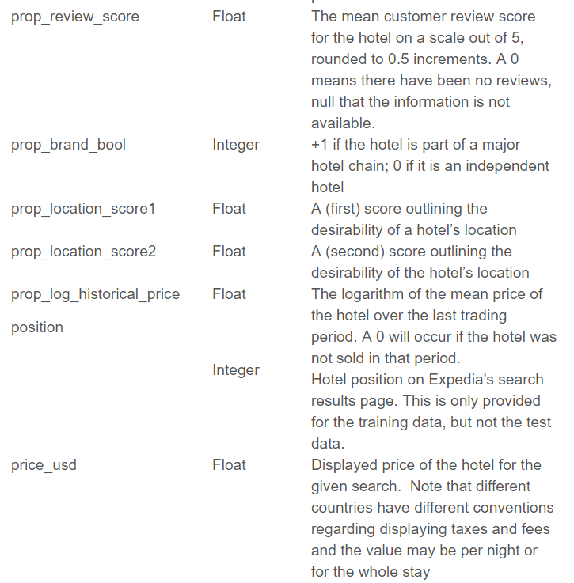

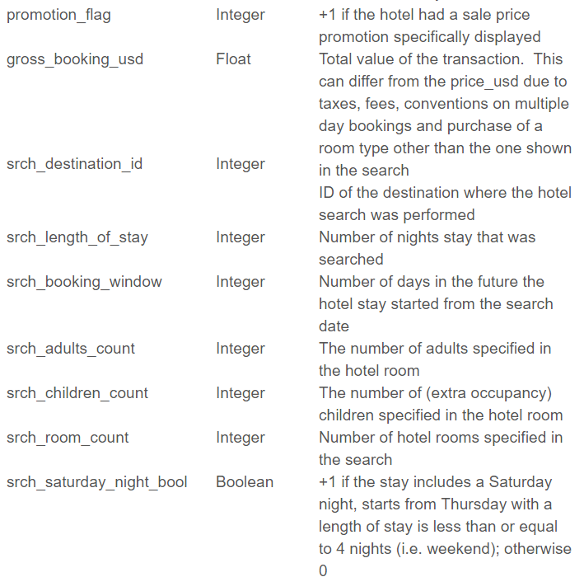

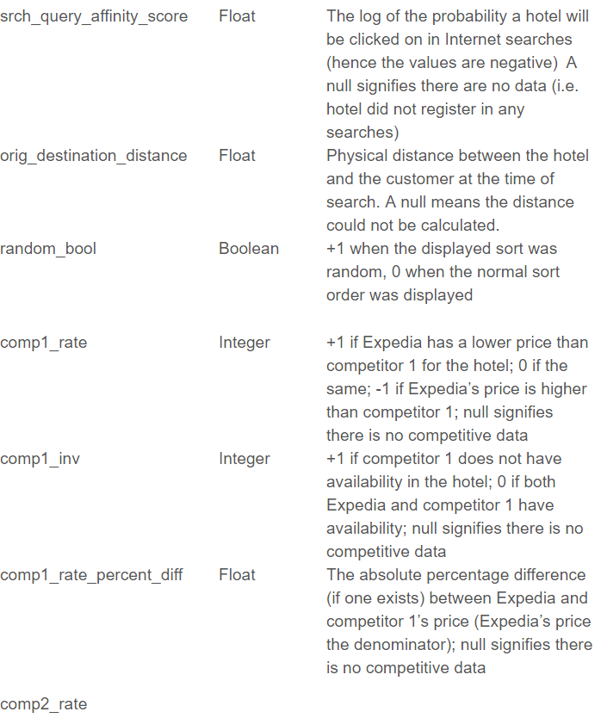

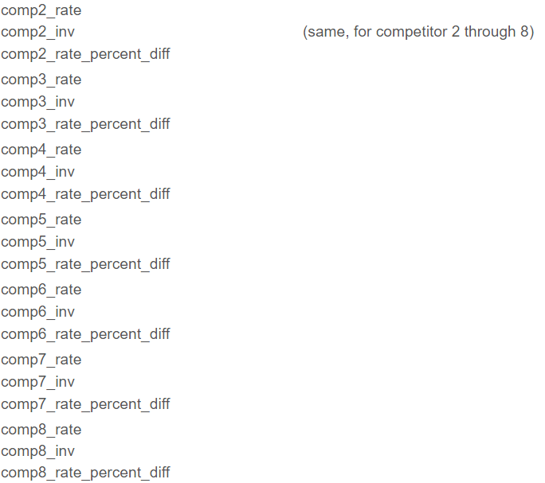

Train.csv

Expedia Hotel Site and Hotel ID

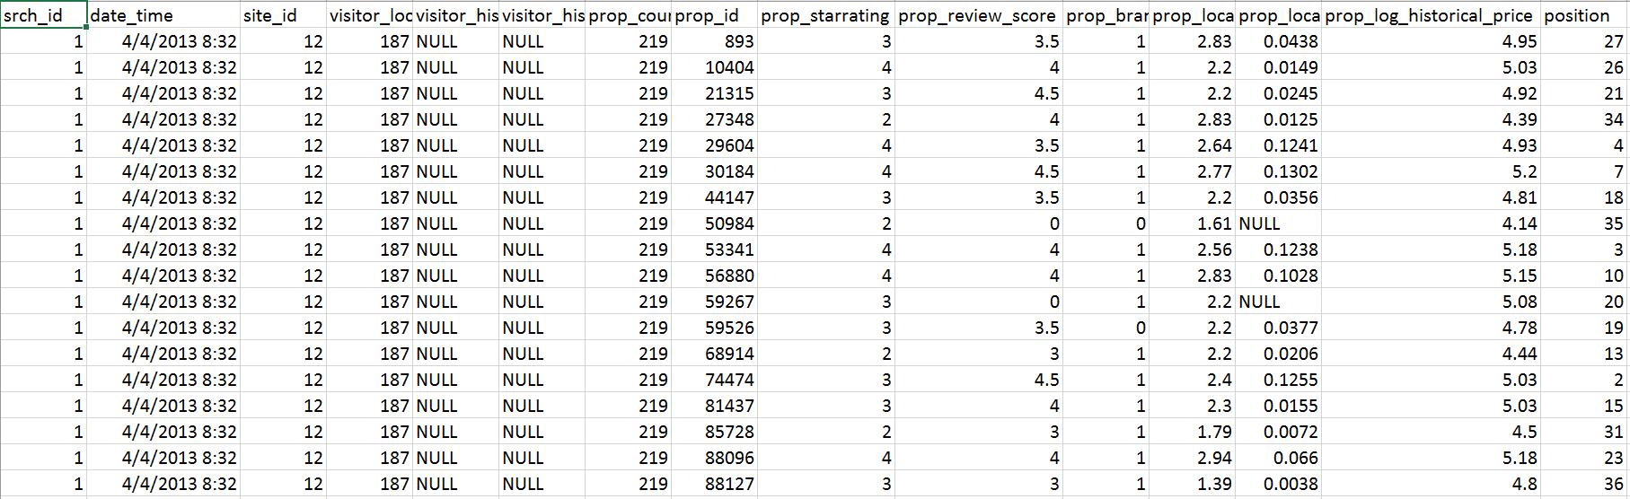

Search Query data

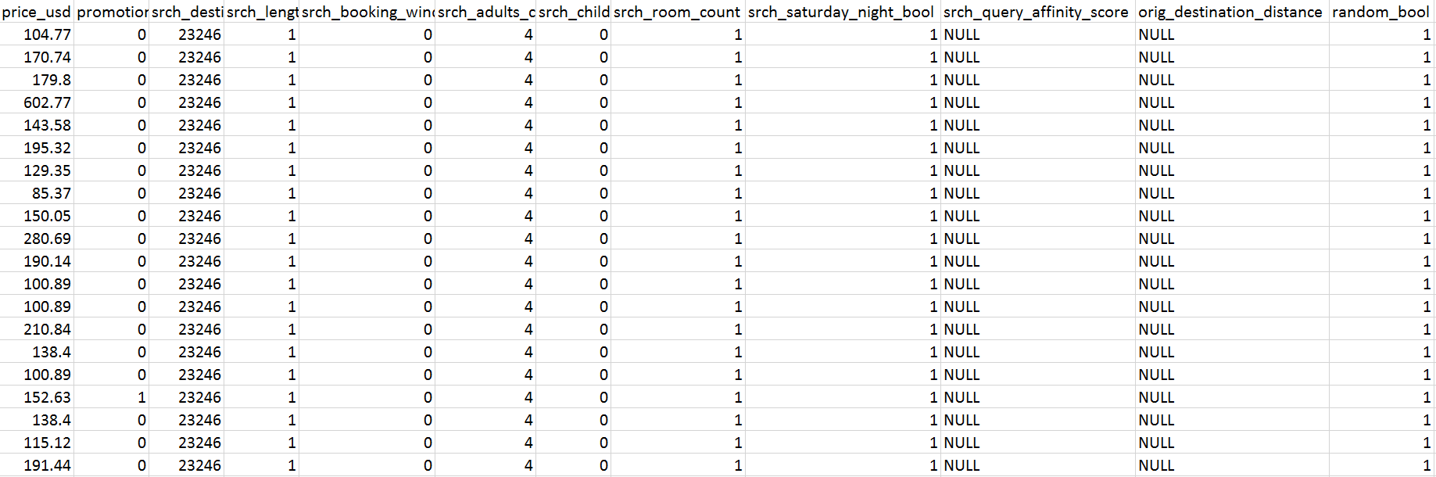

Competitors Data

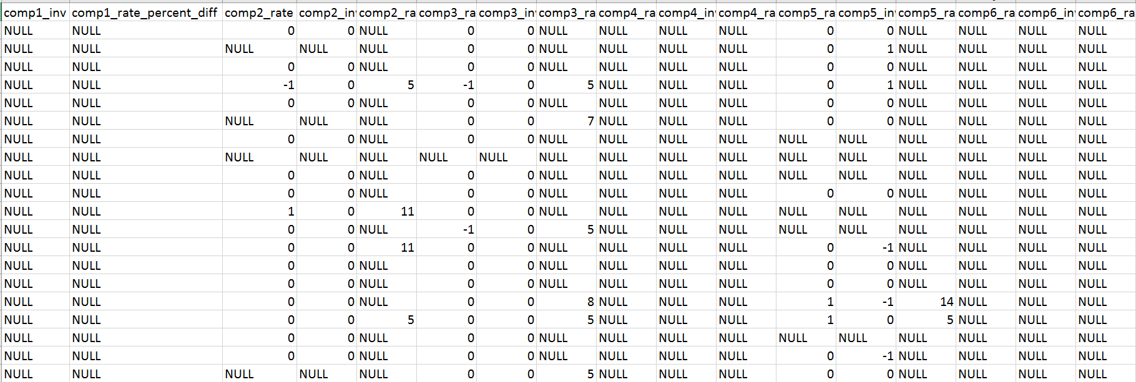

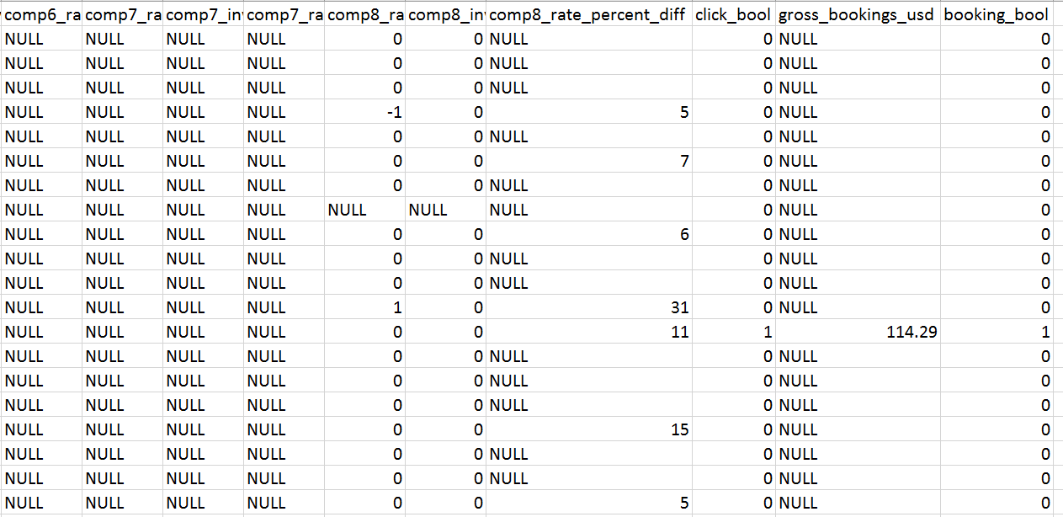

There is another data which is used for predicting the output of the search query, i.e., in which hotel user is going to book the hotel. The data is in CSV format and is of size around **4GB**. Below are the column descriptions for the data set.





DATA PREPROCESSING

**R Script – Preprocessing.R**

Initially we are going to set the working directory for the personalized searching ranking input file i.e., train/test.csv to clean it. After that we are going to install the libraries like 'xgboost', 'caret', 'ggplot2', 'plyr', 'dplyr', 'gbm'. XGboost is the prediction algorithm which is used for ranking the prediction. After installing we load the libraries.

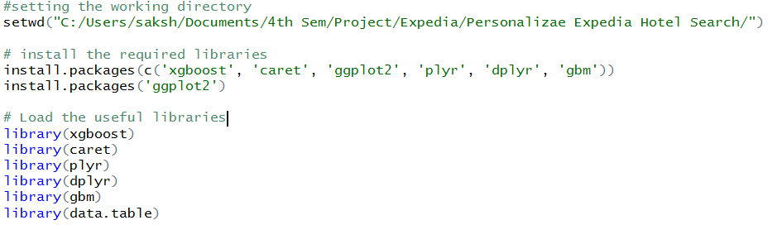

We are loading the training and testing data using fread which is the function in data.table which reads the data very fast compare to read.csv, since our data is approximately 4 GB we need to use this.

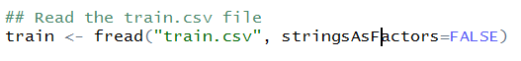

After reading the file we can look the structure of data to find out what is the column class.

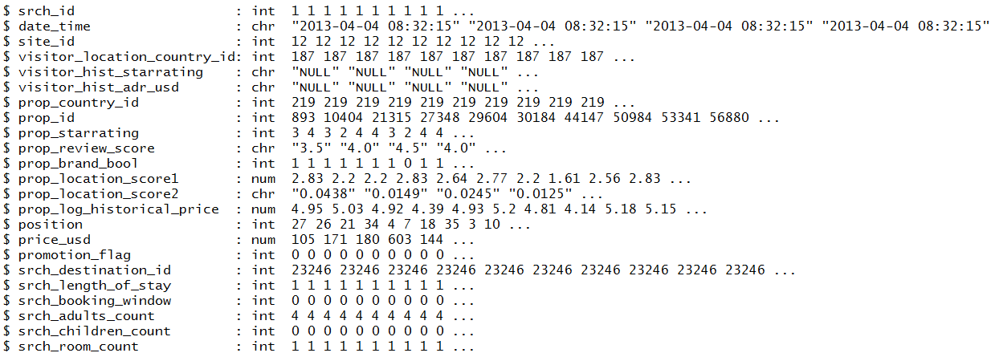

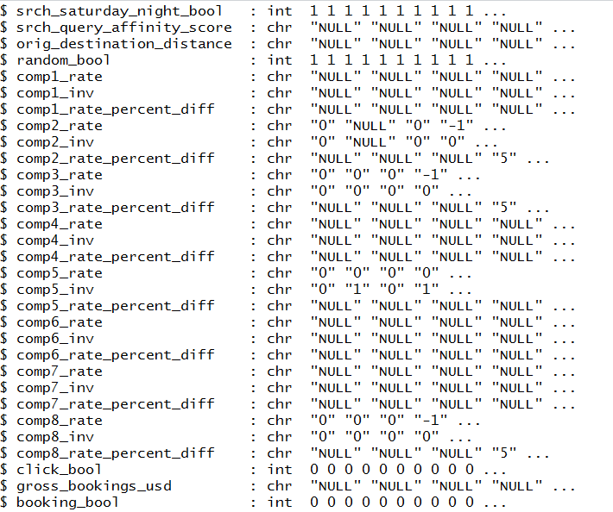

* **Data Cleaning**

Since for any algorithm we need all the attributes to be in numeric, we are going to convert factor, character and int to numeric so that later we can look for outliers and missing values. We are going to use as.numeric function to convert the data to numeric.

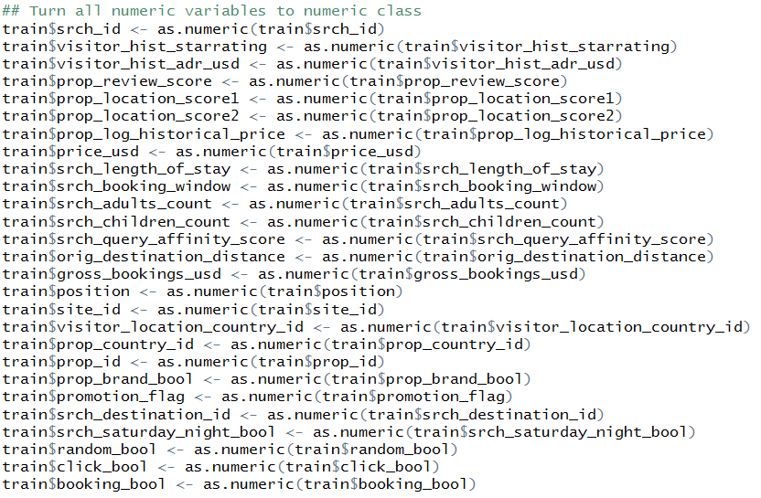

We are going to convert date from character class to POSIX

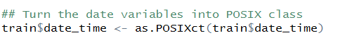

In competitive rate we have lot of null values, as the rate and difference is missing for most of the competitors and expedia has also tried giving the price for 8 competitors, so we are going to replace the NULL values with zero (0).

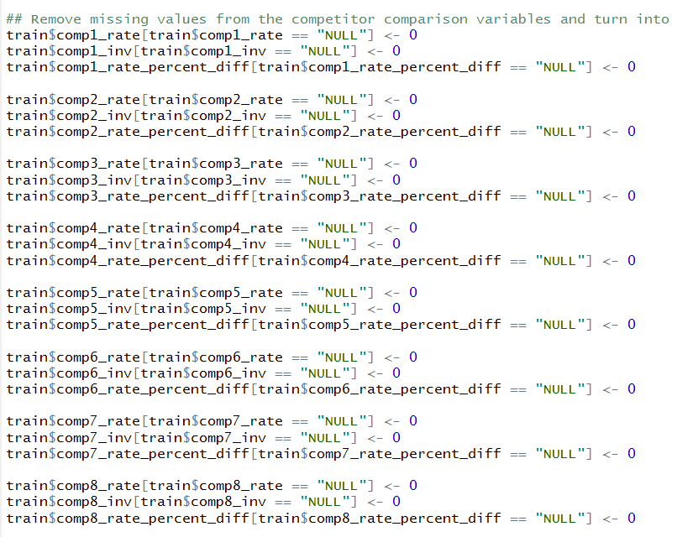

These competitive rates are in factor so we have to convert the factor to numeric.

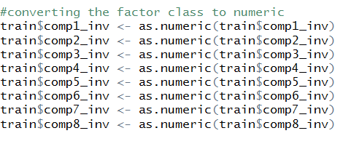

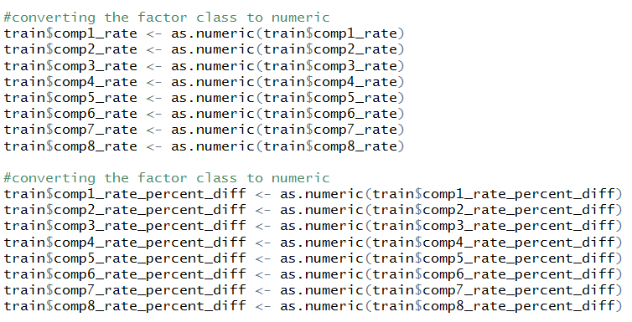

We are also given the property score 1 and score 2, it also consists of **NA values,** i.e., also considered as missing values and we have to consider that as well. So we are going to replace NA values with zero for both the property score

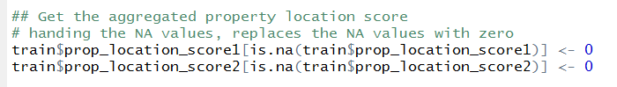

For the few hotels we have been given review score as NA, as said earlier that is also a missing value, we are going to replace the NA values with zero



* **Feature Engineering**
* Generating the aggregate score by adding the score 1 and score 2 and assigning the value to new column.

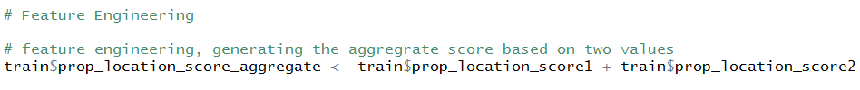

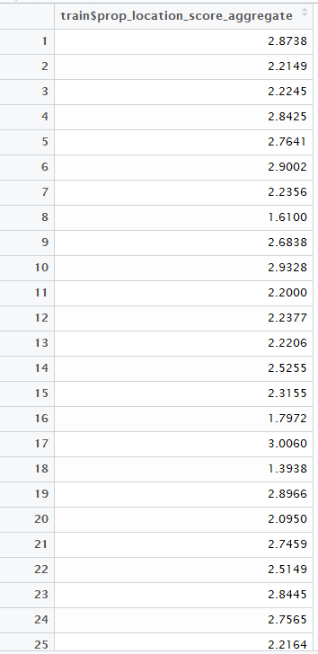

* Getting the mean historic price



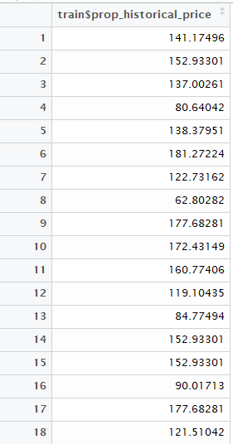

* After getting the mean historic price, we are going to calculate the difference between historic price and current price

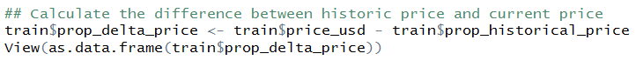

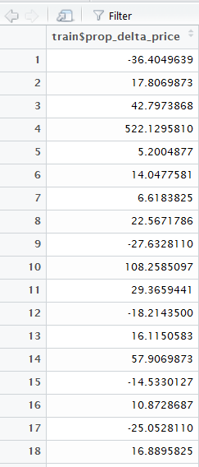

* Get the price order within the same user search

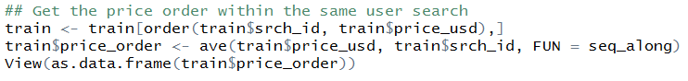

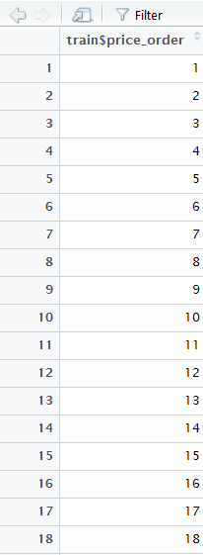

* Get the target date for reservation

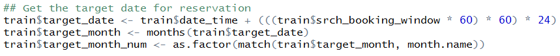

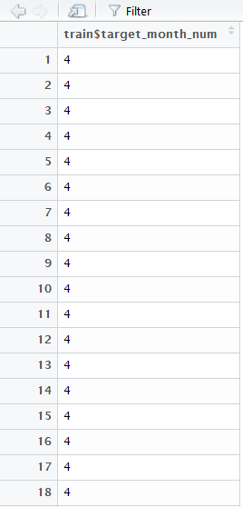

* Writing the clean train file to the directory to the file

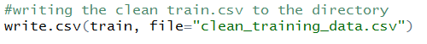

We are going to perform all the same process to the test.csv file, because earlier we used to forecast we don’t need the test file, but in this case the user is going to make the query and then we are going to the hotel ids which are available and then we are going to sort the hotel ids in the order they are going to shown to the user. In the test data, we are not given the **click_bool** and **booking_bool** for the hotel ids, Therefore, we need to predict the click rate and then booking rate and after that we are going to predict the position.

* **Cleaning the Test Data**

**R Script – PreprocessingTest.csv**

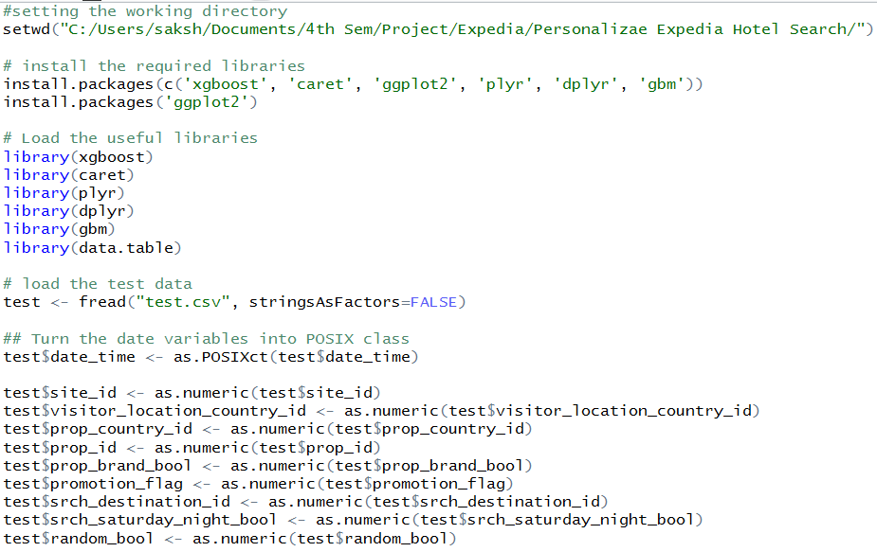

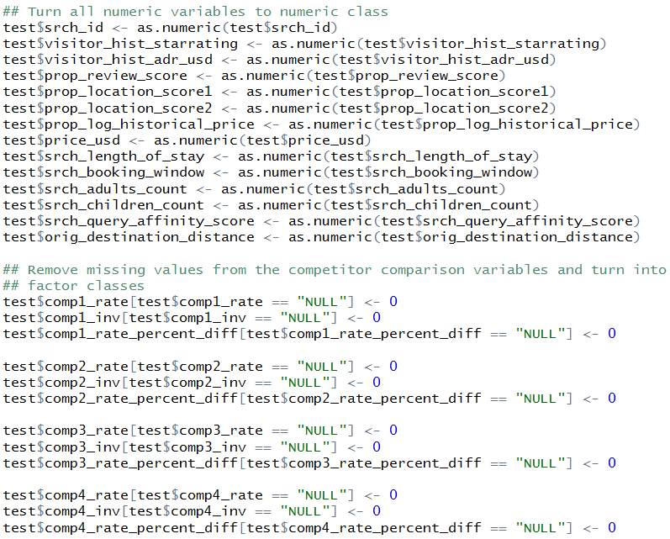

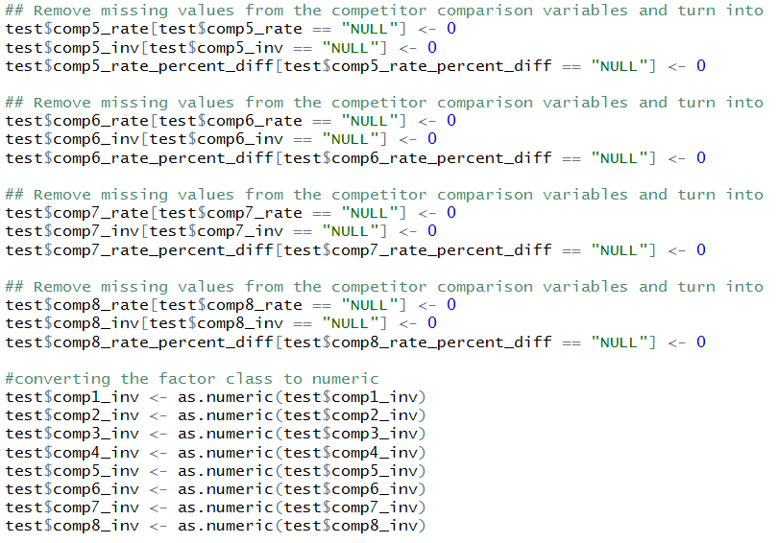

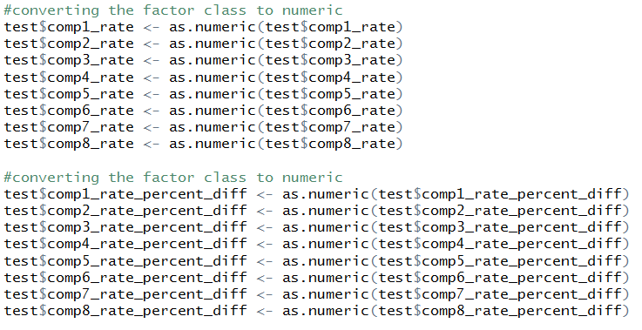

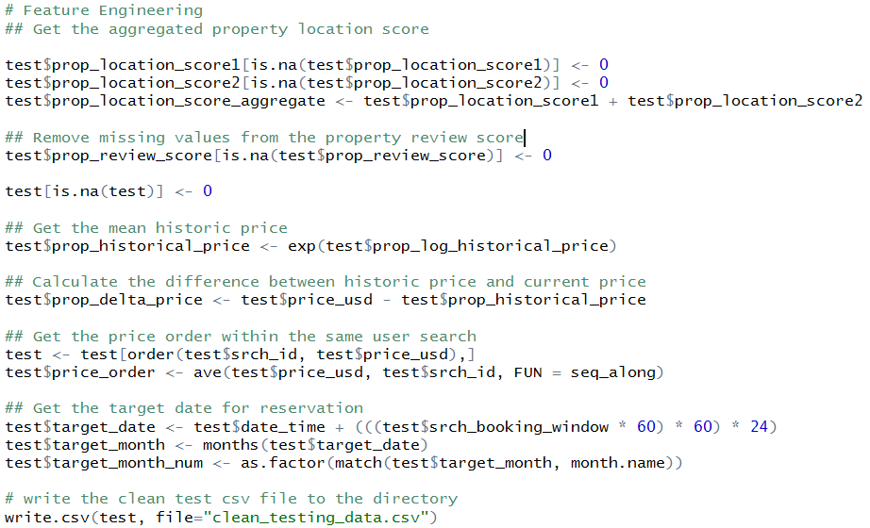

**Cleaning the dataset 2 for cluster**

**R Script – DataWrangling.R**

Initially we are going to set the working directory for the hotel recommendation input file i.e., train/test.csv to clean it. After that we are going to install the libraries like ggplot2, caret, dplyr. After installing we load the libraries.

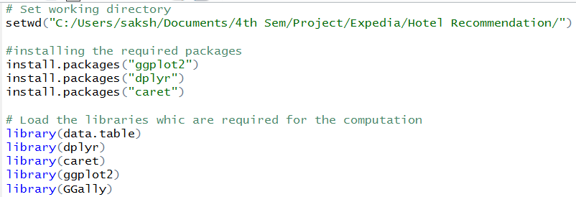

We are loading the training and testing data using fread which is the function in data.table which reads the data very fast compare to read.csv, since our data is approximately 4 GB we need to use this. Since before we proceed to any cleaning we are going to use the 2 percent of the data for data analysis what all columns are there and what are the missing data or outlier, so that we can get the gist of the data. Split Index is for diving the data equally based on the number of clusters, since we have 100 clusters we don't want our data to miss any of them, therefore we use this function. That is how although we are considering only 2 percent of the data but it will have all the cluster equally as they are present in the original data.

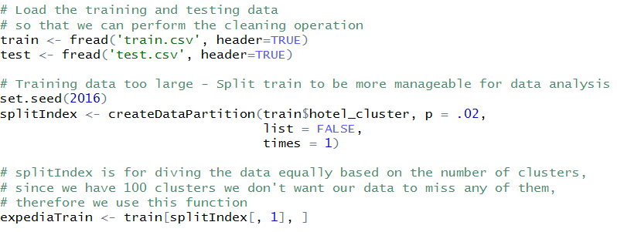

1. **Data Cleaning**

Once we have the 2 percent data, we are going to compute the total NA count in the training dataset.

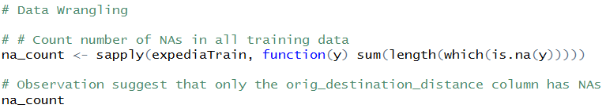

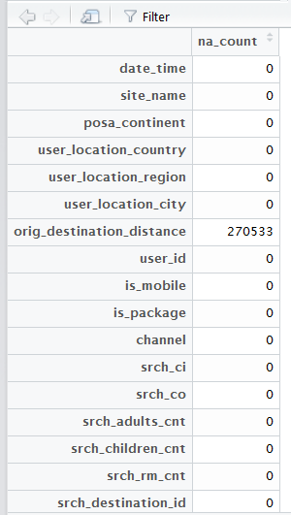

It seems that only the orig_destination_distance column has NAs. Now we are going to compute the total percent of dataset has NA’s based on the column orig_destination_distance.

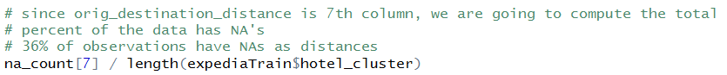

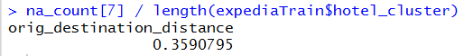

Since we have 36% of the NA in the orig_destination_distance, we cannot ignore or remove those rows from the dataset, which is not usual. So therefore in this case, we are going to replace the orig_destination_distance with the mean of the column, which is the basic technique for handling missing data and we are going to assign it to new column **dist1**

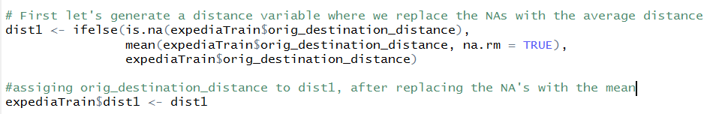

1. **Feature Engineering**

Since we have handle the missing data, and data cleaning is done, we are going to do some feature engineering.

* We are going to find the month of holidays, that is, the month when most of the hotel’s are booked or the month for which most queries are being done.



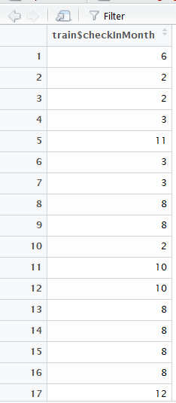

* After getting the month of holiday, we are going to generate the measure to indicate popularity of hotel_cluster in each destination.

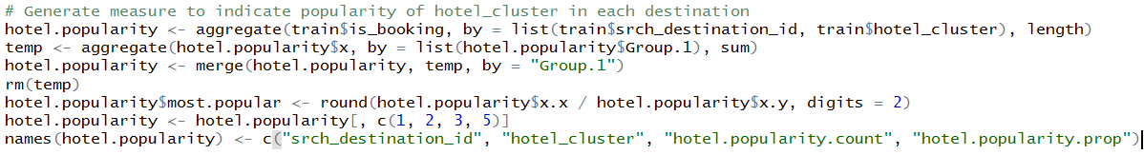

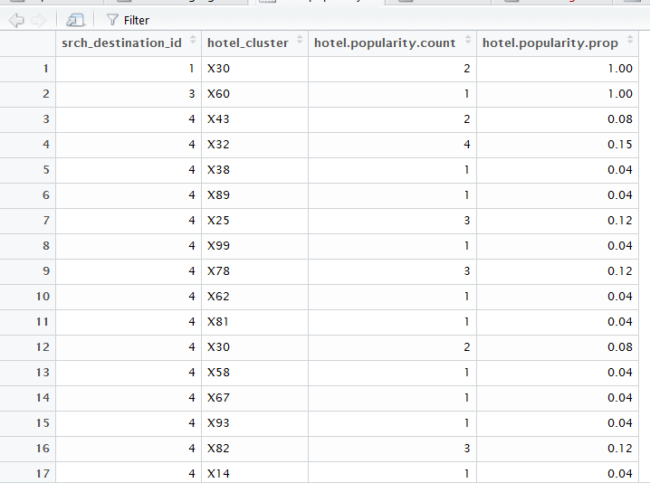

* We are going to generate tag to indicate top 5 hotel_clusters in each destination

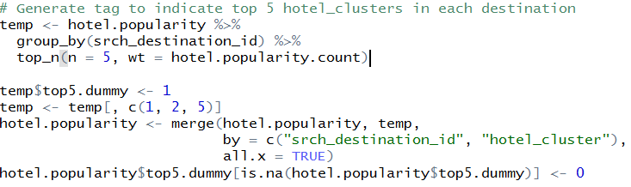

Writing the file to the **expediaData.csv** so that we can use the file for training the model and predicting the values. We are going to implement **Random Forest, Neural Network and Decision Jungle.** The one with the best accuracy is going to be expose to the front end, which is used by the business user to get the prediction.

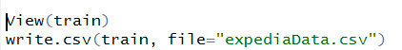

* **Clean Train File**

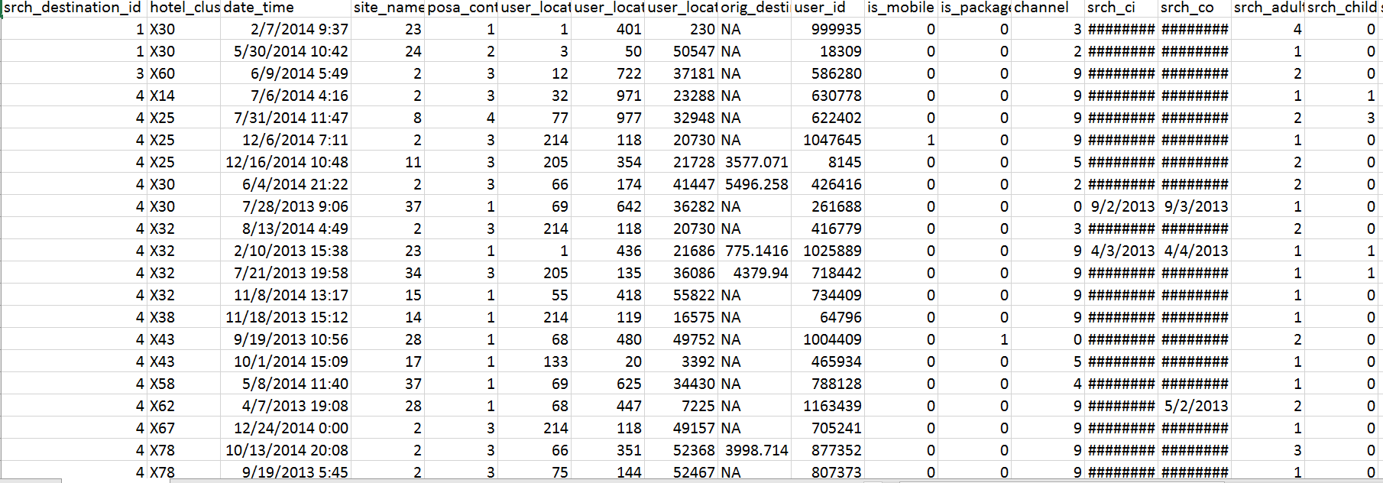

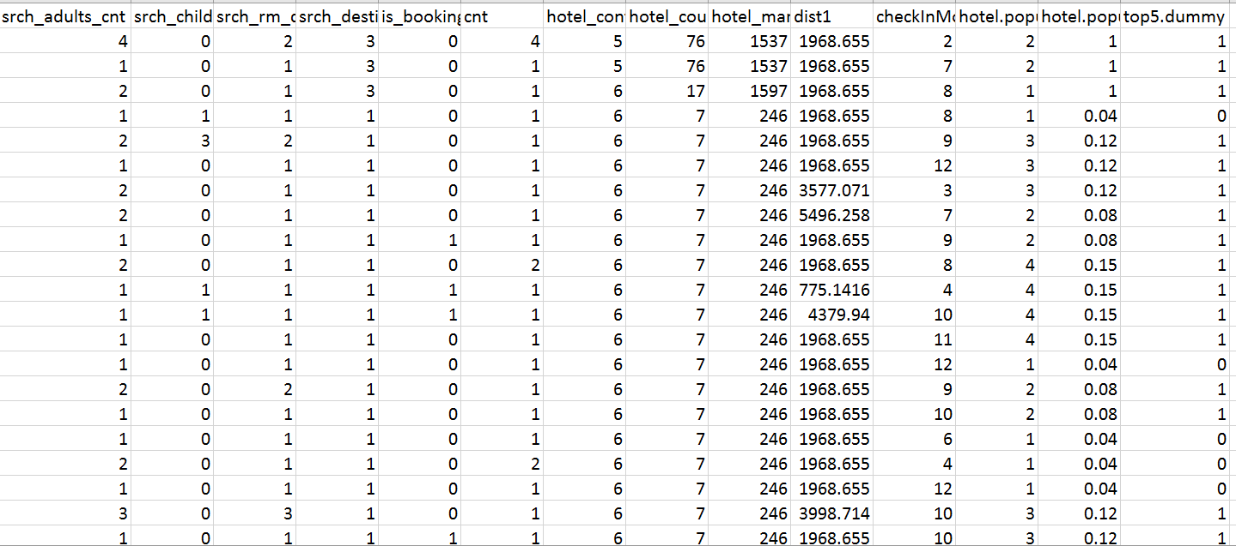

After cleaning all the files we are going to put all the files in the Apache Hive, where we are going to write Map Reduce jobs on the data or Hive Query so that we can perform some visualization and later we can use hive to retrieve data while performing the prediction. We are using Hive because of the amount of data which is available traditional databases are not efficient with the amount of data available.

APACHE HIVE

Hadoop is an open source framework to process huge and voluminous data in parallel environment. Apache Hive, Pig & Sqoop are some of the tools designed on top if Hadoop map-reduce paradigm. The entire purpose of developing these technologies was to allow a user to effectively consume these wonderful, fast and efficient storage and processing technologies without having to worry about skilled resources. Or to deal with configuration, or to redesign their entire application to suit the needs of map-reduce framework.

For our project, Apache Hive is the epicenter of communication or integration to all the technologies involved as a whole starting from Azure ML, Kafka to Stanford API consumption.

We utilized apache hive to save the data consumed to run machine learning algorithms, then we ran some Stanford nlp based sentiment analysis to evaluate a user review and saved that data into tables.



Following are the tables we created in hive to support all storage related operations in our project:

1. Expedia_hotel_cluster
2. Expedia_hotel_review
3. Expedia_hotel_search
4. Expedia_rankings
5. Expedia_rankings_competitive_high
6. Expedia_rankings_competitive_low
7. Expedia_reco
8. Hotel_review_kafka

Setting up configurations is really tricky in hive. Because of lack of documentations or resource examples, the visibility of the way hive can be consumed into industry is really thin.

Essentially, for hive to work on a server, as we had user interface and other utilities utilizing hive as storage. So the connectivity or integration between hive to act as server based and essentially allow java programs to access tables, trying to write sometimes or read.

There are three services to be up, before we can consume server services from anywhere:

1. Hive Metastore
2. Hive Server2
3. Hive Beeline

There is a configuration file named hive-site.xml which needs to be tweaked before running Hive. And there are close to 100 odd configurations to be set. Most of them will be the default values unless someone trying to implement separate partitioning of data. Allowing access to hdfs & hive as well to specific users using the storage.

Process to start hive on hdfs:

Start metastore



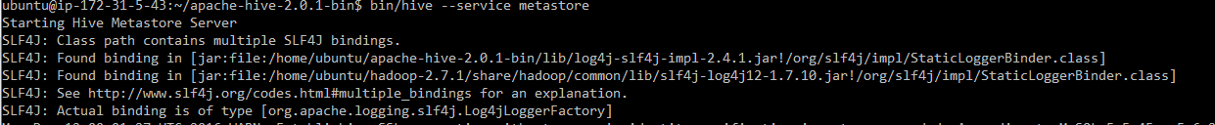

Start hiveserver2

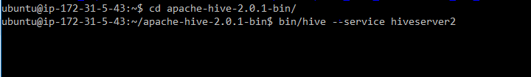

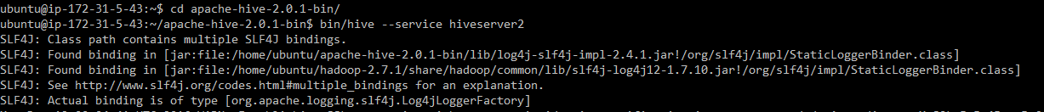

Start beeline



To check whether all three services are running:

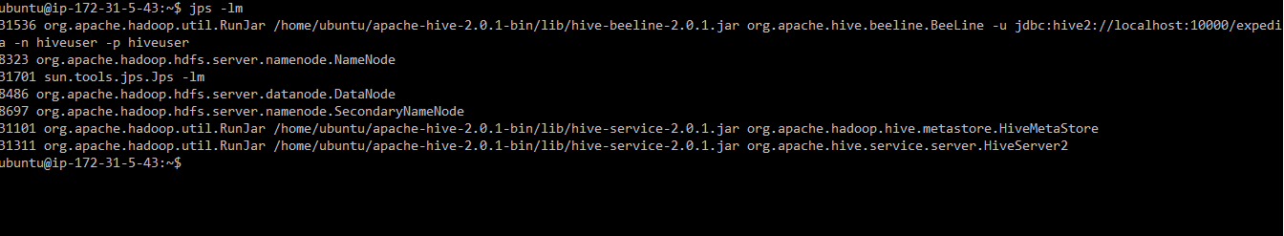

Since there were multiple ways in which hive was getting consumed in UI and kafka as well, we created HiveDAO named class to handle all the communication with hive:

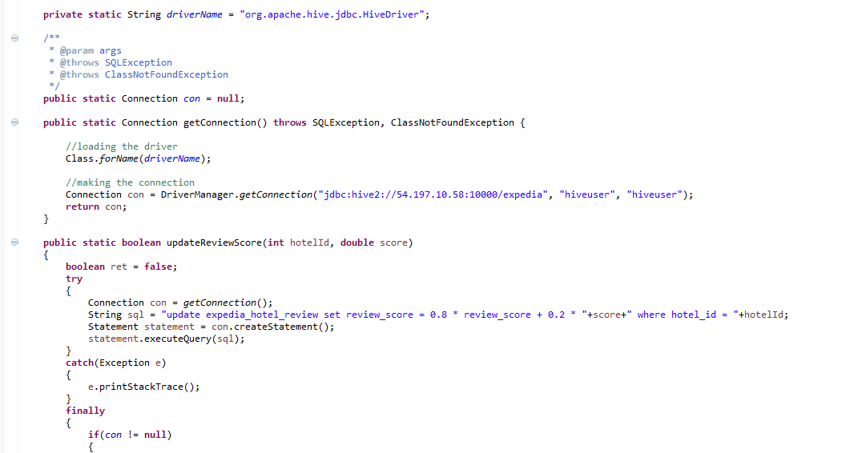

Functions:

1. getConnection():

Establish a connection with hive database and provide the connection instance to the calling function.

1. updateReviewScore():

For each and every instance of a new review for a hotel, score gets calculated using stanford nlp and the score has to be updated in the hive tables with respect to particular hotel identification.

Since there is already some value available in the tables we use one specific formulae to calculate new review after considering 30 reviews score: 0.8x + 0.2y = review score.

X = old review score; y = new review score

To facilitate web-ui effective retrieval of data from hive, we have created following class:

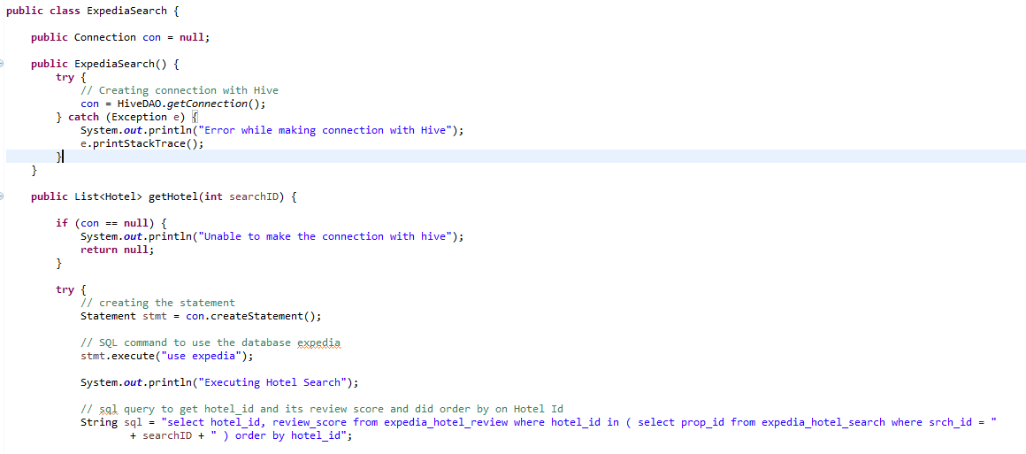

Functions:

1. getHotel(search id)

This function triggers a hive query providing search id from UI to facilitate data retrieval. Each hive query essentially runs series of map-reduce jobs to either read or write data.

1. getHotelById(hotelId)

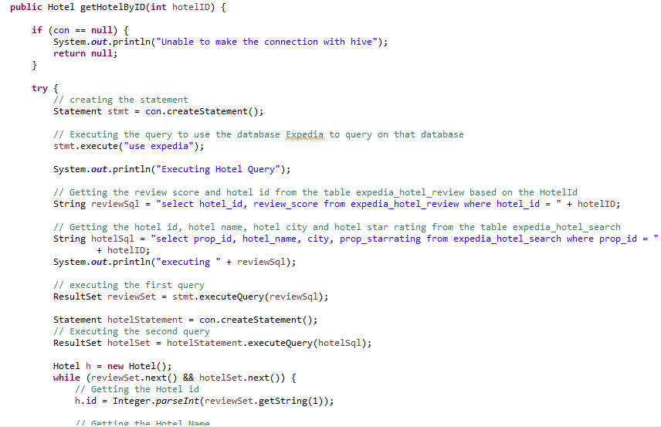

This function helps us with all the details or information available about one particular hotel. One query gets all the details for us using hotel_id.

1. getHotelByCluster(clusterId)

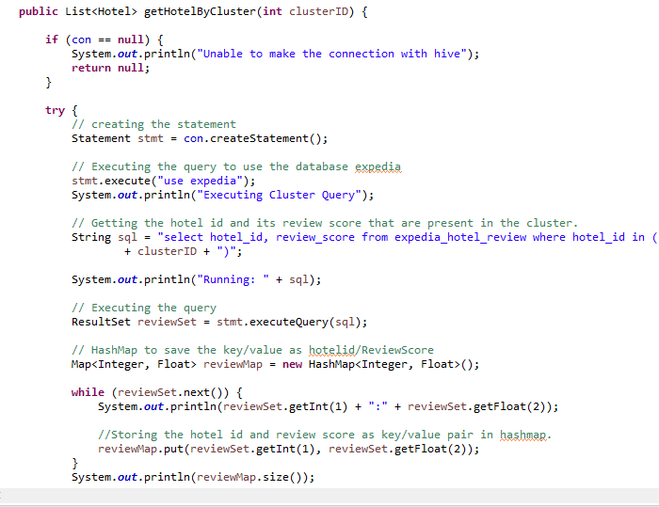

This function helps us with getting a list of hotel_ids with based on cluster_id provided. A query runs at back end to support this transaction with Hive utilizing HiveDAO to get connection.

TOOLS

**EC2**: We have setup Amazon EC2 as our server, we have setup Hadoop, Apache Hive and Apache Kafka

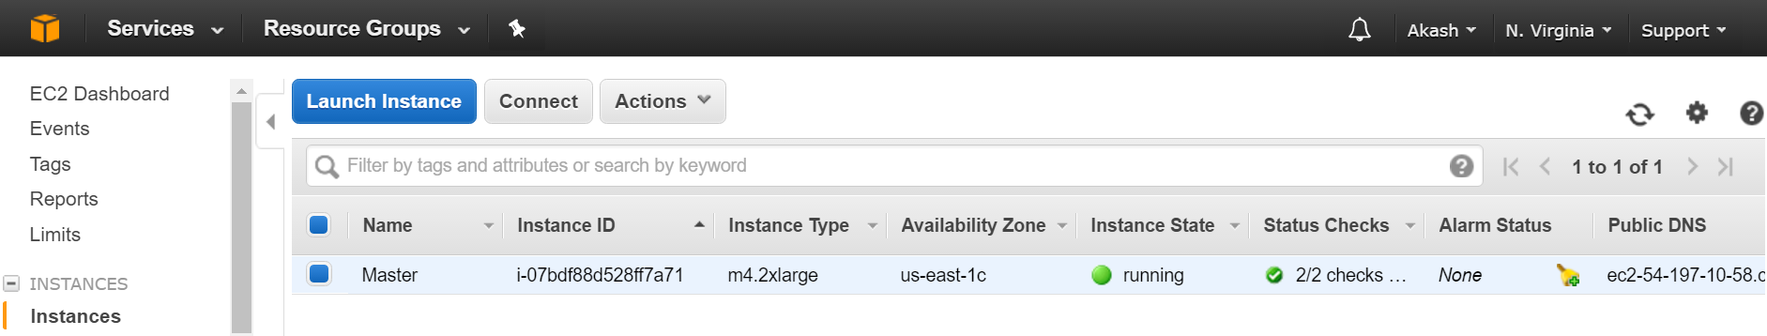

This is the number of things all the time

* Hadoop
* Metastore
* Hive Server
* Beeline
* Kafka-zookeeper

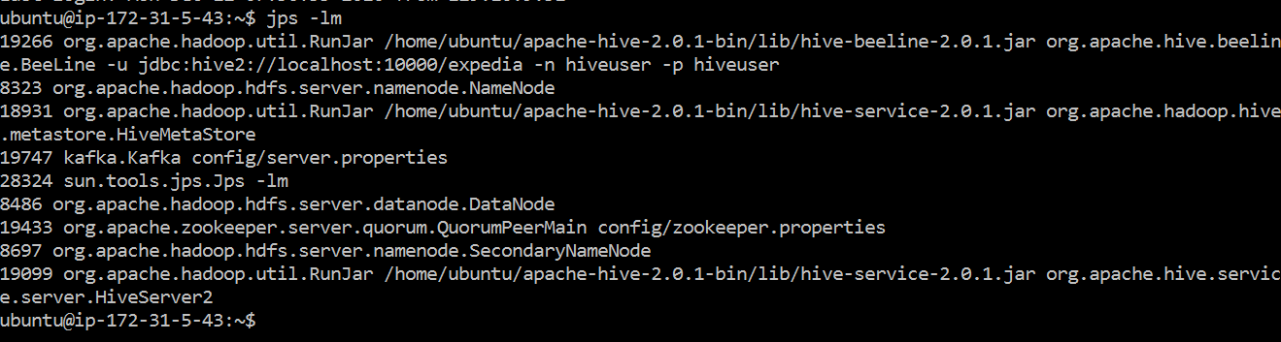

Tables within Hive

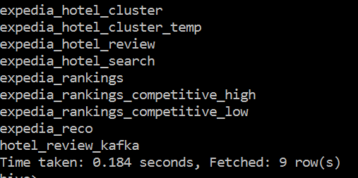

Setting up Single Node Cluster

Develop 3 VM’s with Adapter settings as “NAT” and “Host-Only VM”

1. Install Java

Using commands

$ sudo apt-get install python-software-properties

$ sudo add-apt-repository ppa:ferramroberto/java

# Update the source list

$ sudo apt-get update

# Install Sun Java 6 JDK

$ sudo apt-get install default-java

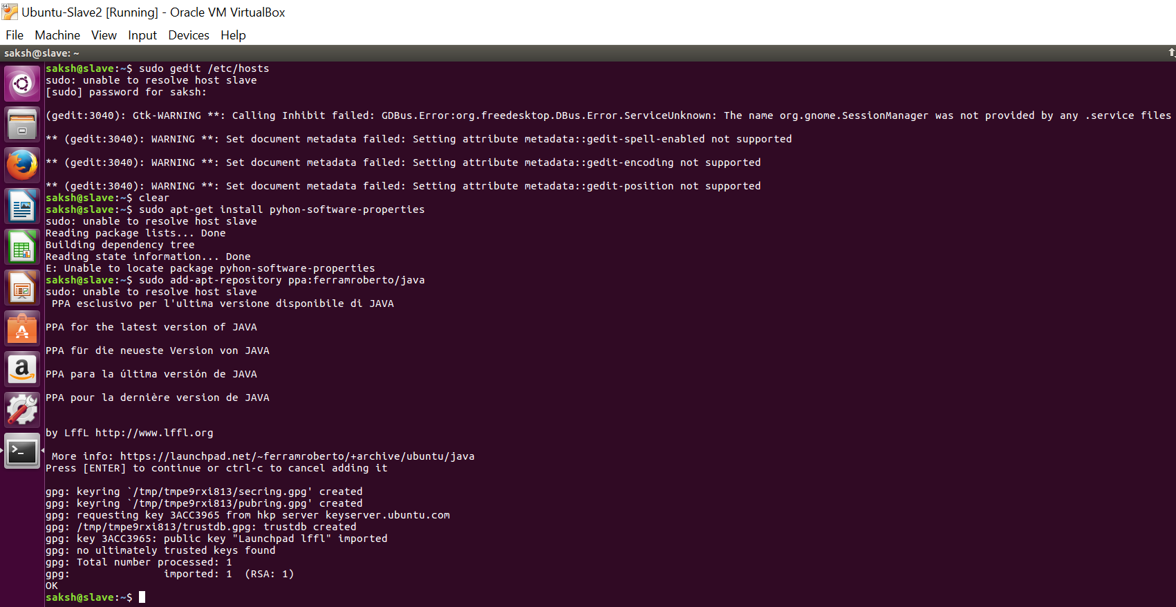

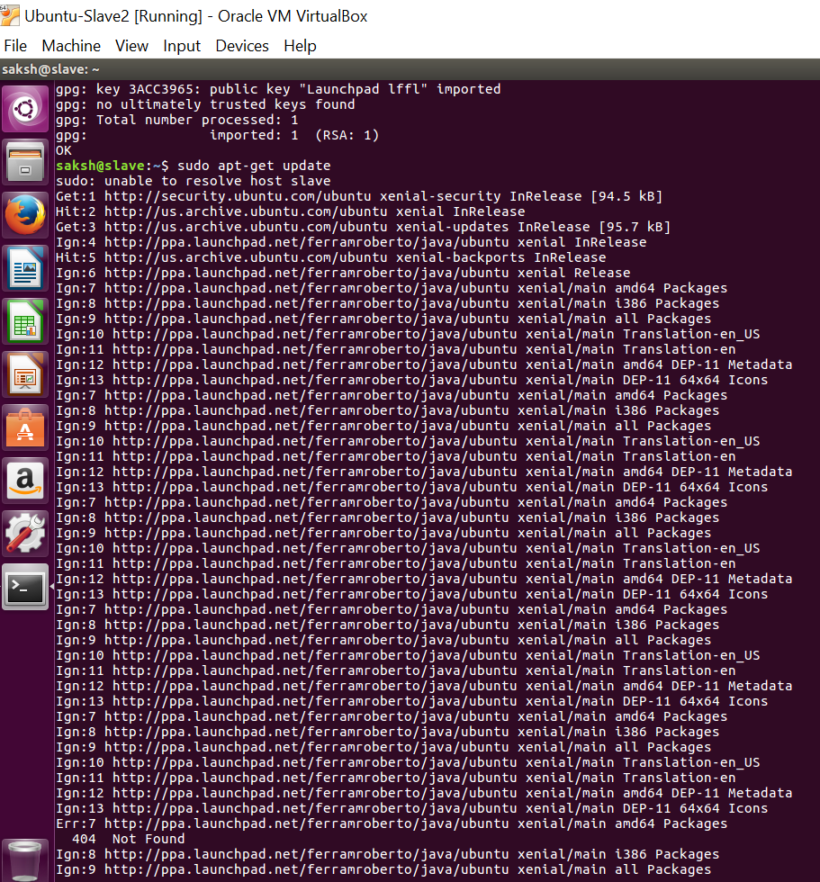

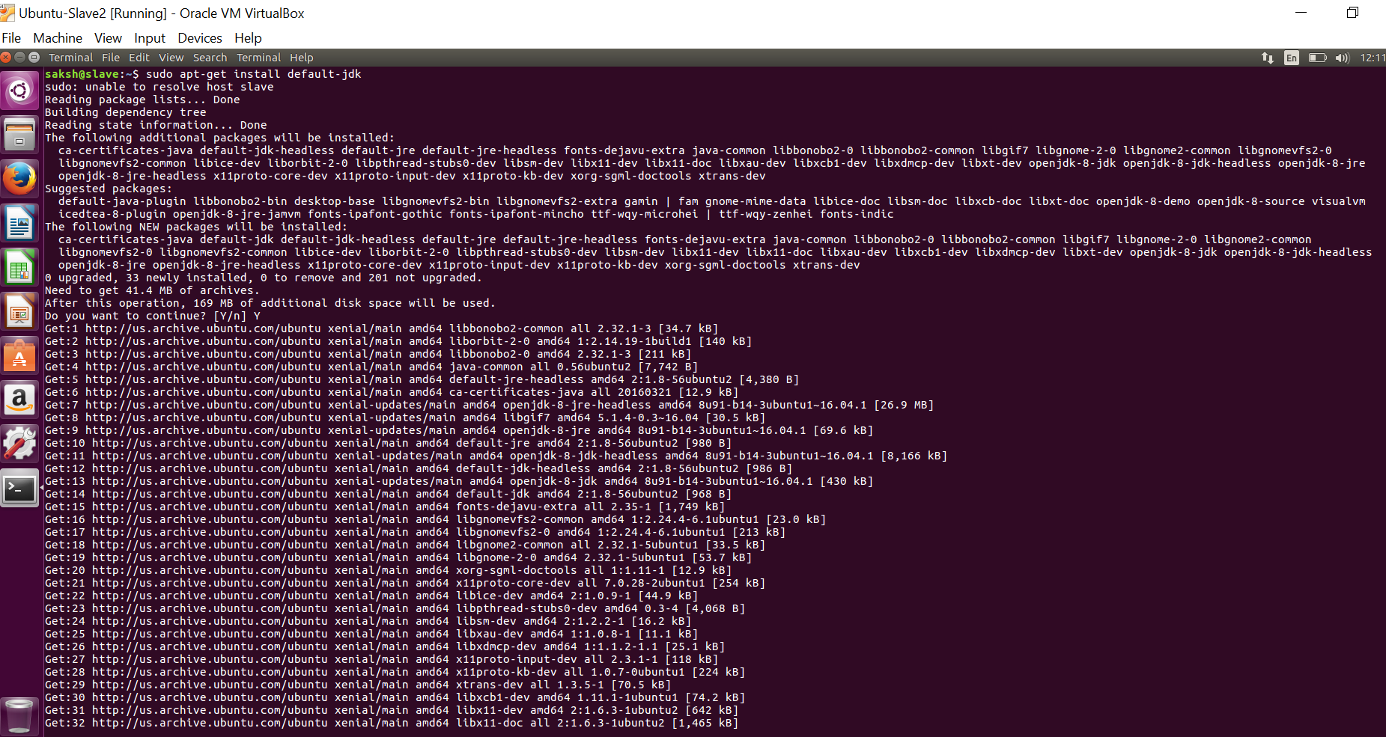

Check for java version using command **java -version**

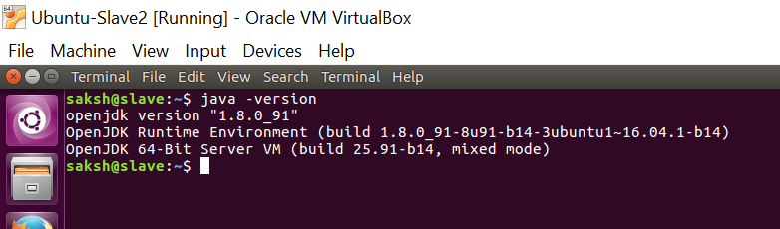

After installing java successfully, Configure SSH

su – saksh

ssh-keygen -t rsa -P ""

Generating public/private rsa key pair.

Enter file in which to save the key (/home/hduser/.ssh/id_rsa):

Created directory '/home/hduser/.ssh'.

Your identification has been saved in /home/hduser/.ssh/id_rsa.

Your public key has been saved in /home/hduser/.ssh/id_rsa.pub.

The key fingerprint is:

9b:82:ea:58:b4:e0:35:d7:ff:19:66:a6:ef:ae:0e:d2 hduser@ubuntu

The key's randomart image is:

[…snippet..]

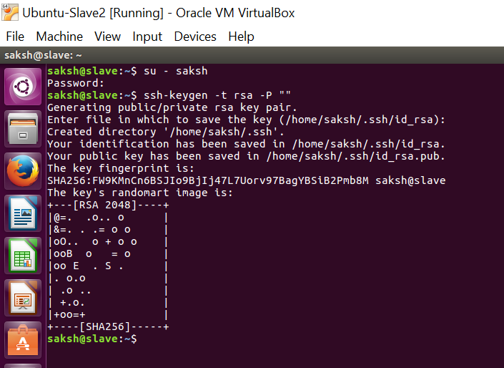

Second, you have to enable SSH access to your local machine with this newly created key.

*cat $HOME/.ssh/id_rsa.pub >> $HOME/.ssh/authorized_keys*

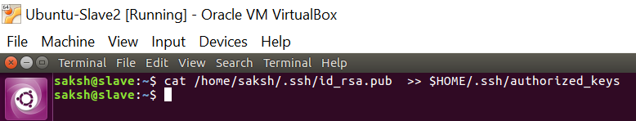

The final step is to test the SSH setup by connecting to your local machine with the hduser user. The step is also needed to save your local machine’s host key fingerprint to the hduser user’s known_hosts file. If you have any special SSH configuration for your local machine like a non-standard SSH port, you can define host-specific SSH options in $HOME/.ssh/config (see man ssh_config for more information).

*Ssh localhost*

There might be an error, connection refused **“Connect to host localhost port 22: connection refused”**

sudo apt-get install openssh-server

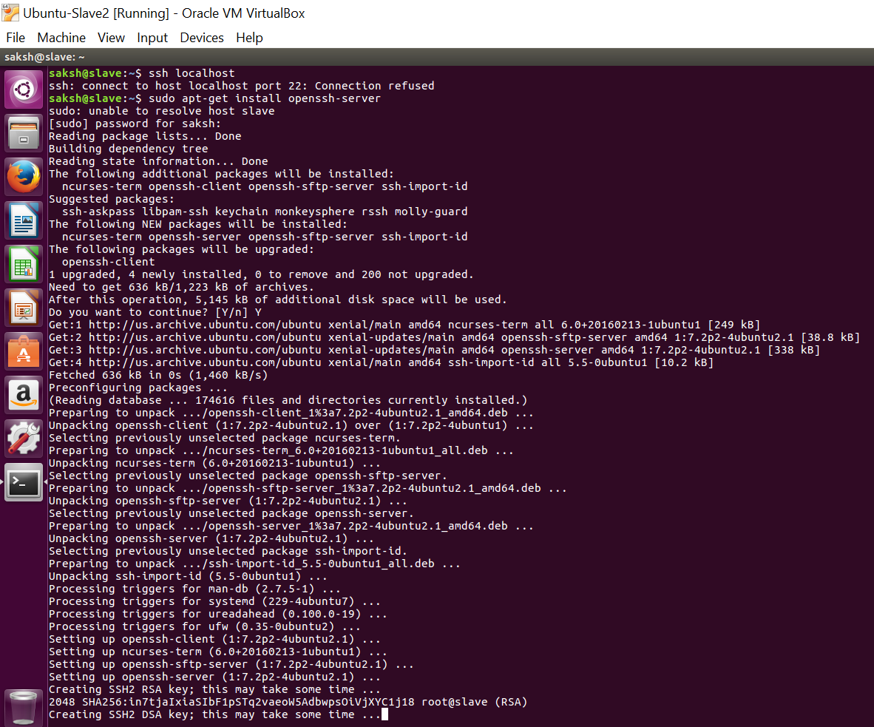

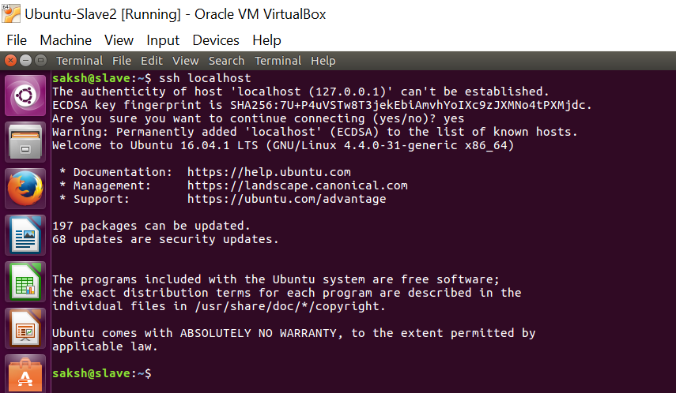

Disabling IPv6

One problem with IPv6 on Ubuntu is that using 0.0.0.0 for the various networking-related Hadoop configuration options will result in Hadoop binding to the IPv6 addresses of my Ubuntu box. In my case, I realized that there’s no practical point in enabling IPv6 on a box when you are not connected to any IPv6 network. Hence, I simply disabled IPv6 on my Ubuntu machine. Your mileage may vary.

To disable IPv6 on Ubuntu 10.04 LTS, open /etc/sysctl.conf in the editor of your choice and add the following lines to the end of the file:

# disable ipv6

net.ipv6.conf.all.disable_ipv6 = 1

net.ipv6.conf.default.disable_ipv6 = 1

net.ipv6.conf.lo.disable_ipv6 = 1

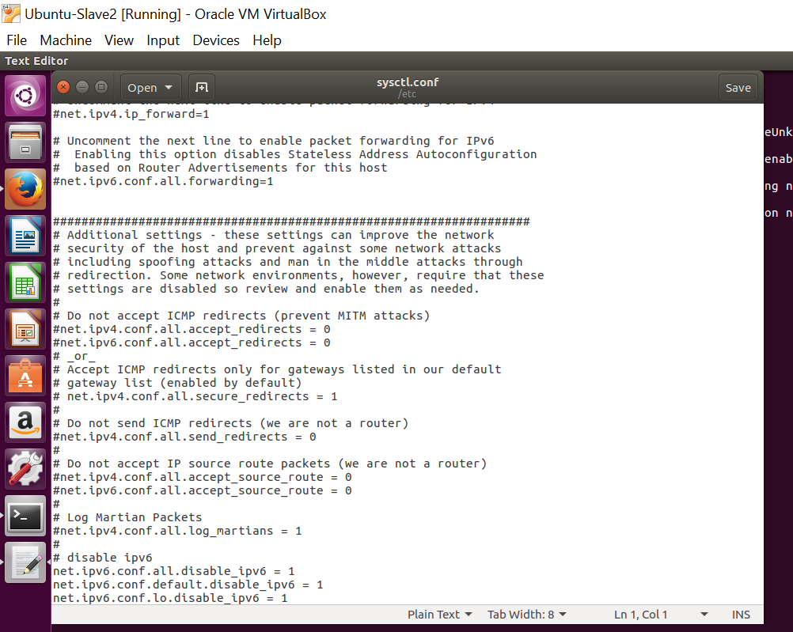

You have to reboot your machine in order to make the changes take effect.

You can check whether IPv6 is enabled on your machine with the following command:

$ cat /proc/sys/net/ipv6/conf/all/disable_ipv6

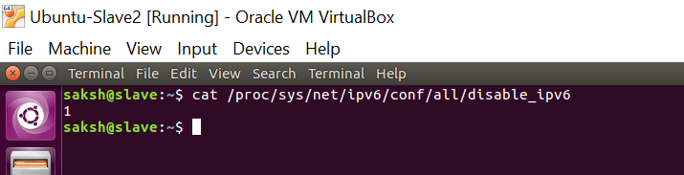

**Hadoop Installation**

Download Hadoop and move it to $HOME or /home/{user} directory

$ cd /usr/local

$ sudo tar xzf hadoop-0.20.2.tar.gz

$ sudo mv hadoop-0.20.2 hadoop

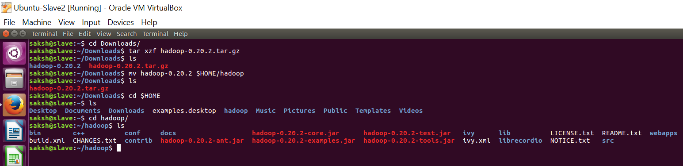

Set the value of JAVA_HOME and HADOOP_HOME in .bashrc file

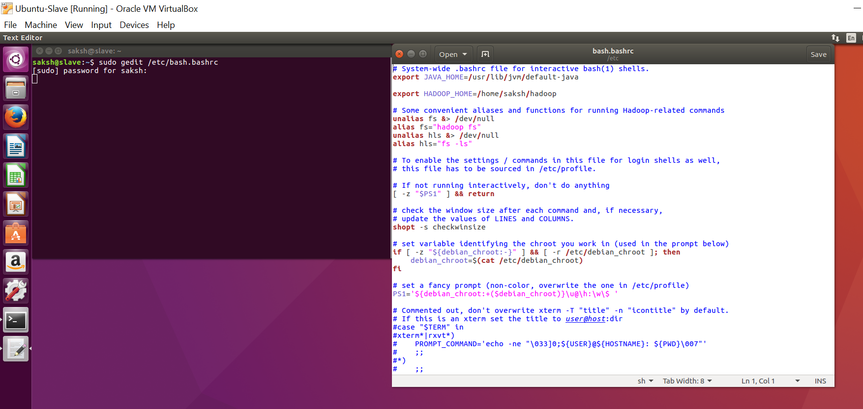

Editing the configuration file of Hadoop

Hdfs-site.xml

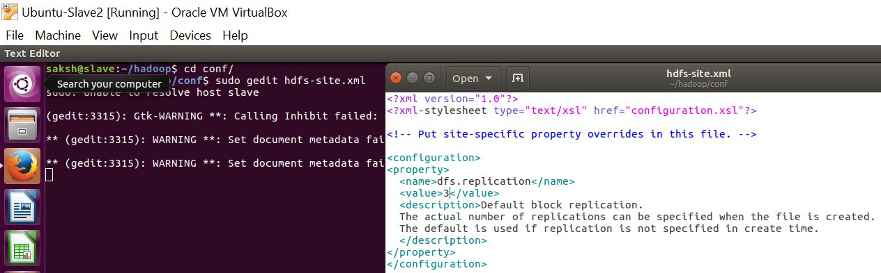

Mapred-site.xml

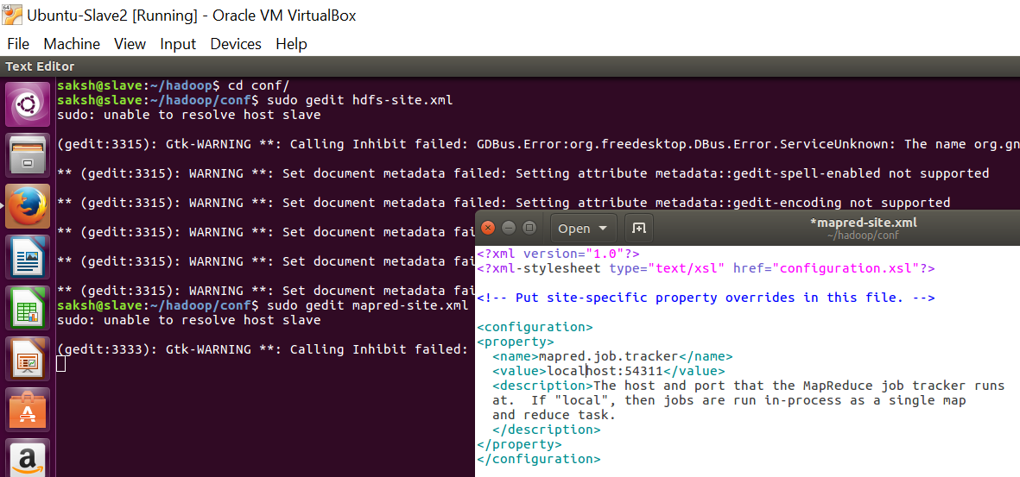

Core-site.xml

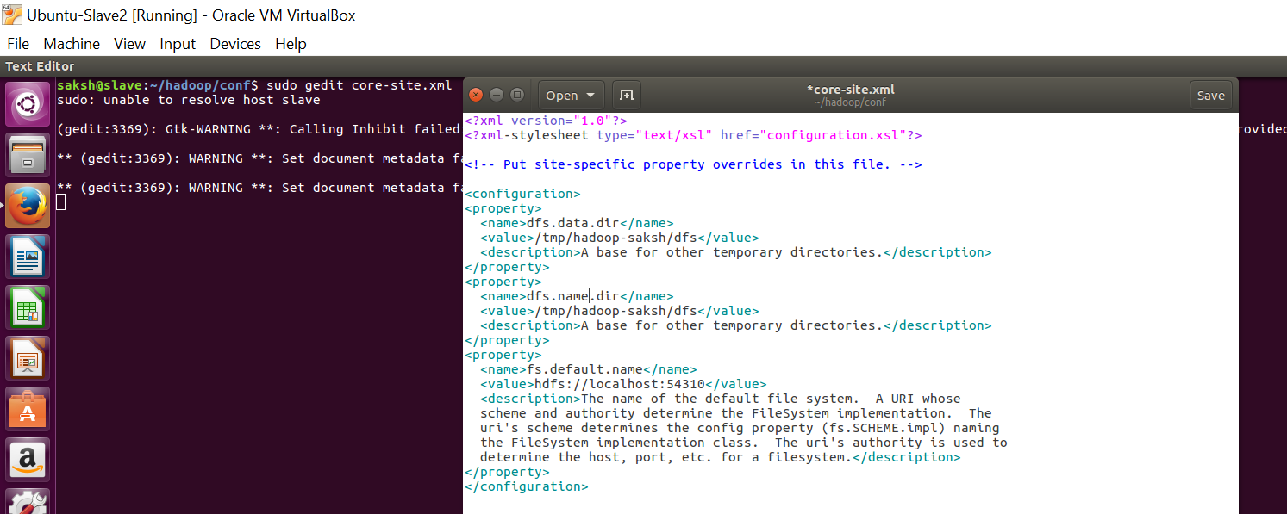

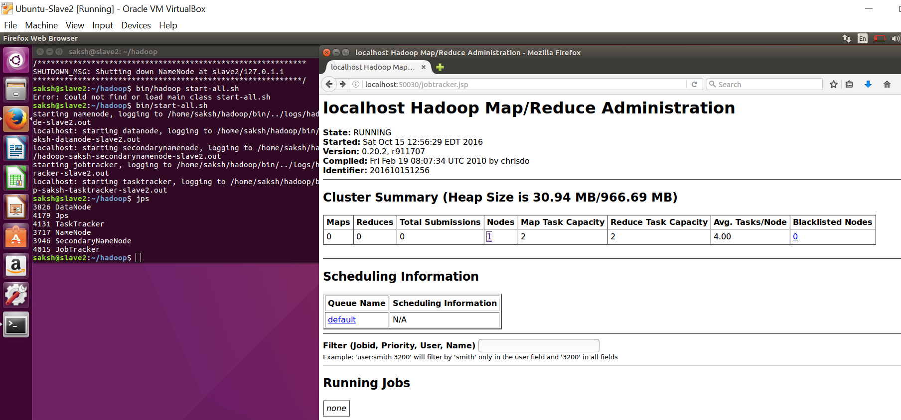

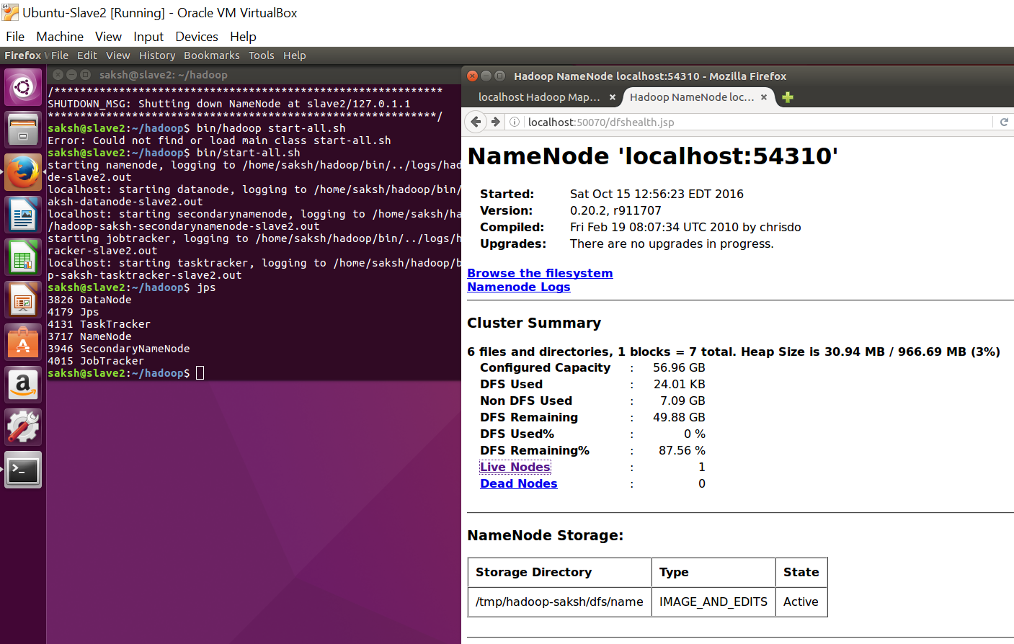

Trend Analysis

Use-Cases

1. Comparing the performance of each Marketing Channel

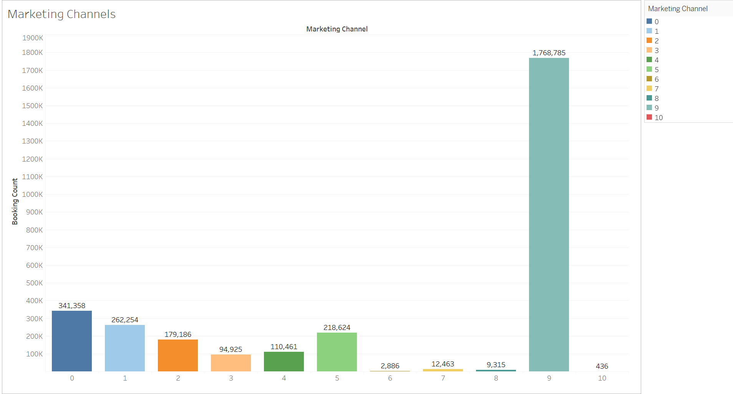

1. Booking based on continents over the time.

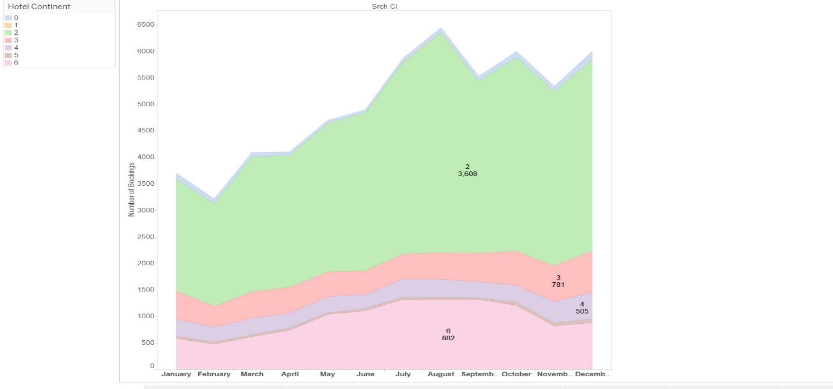

1. Determining the number of clicks per site

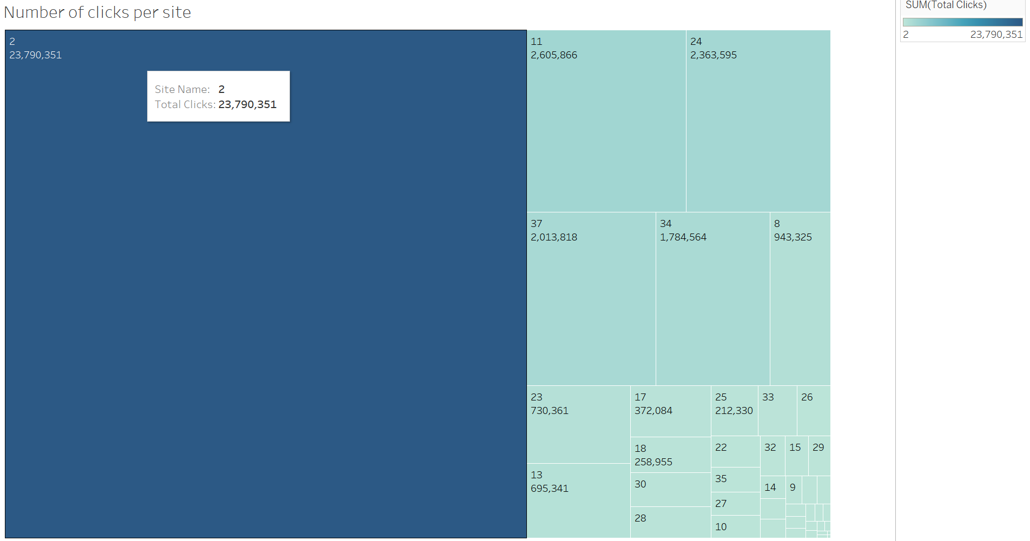

1. Plotting the distribution of hotel clusters in training data

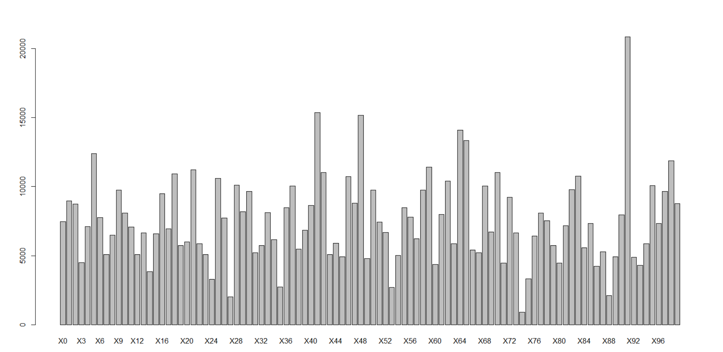

1. Count number of times each hotel_cluster is booked in the training data - to see most popular hotel

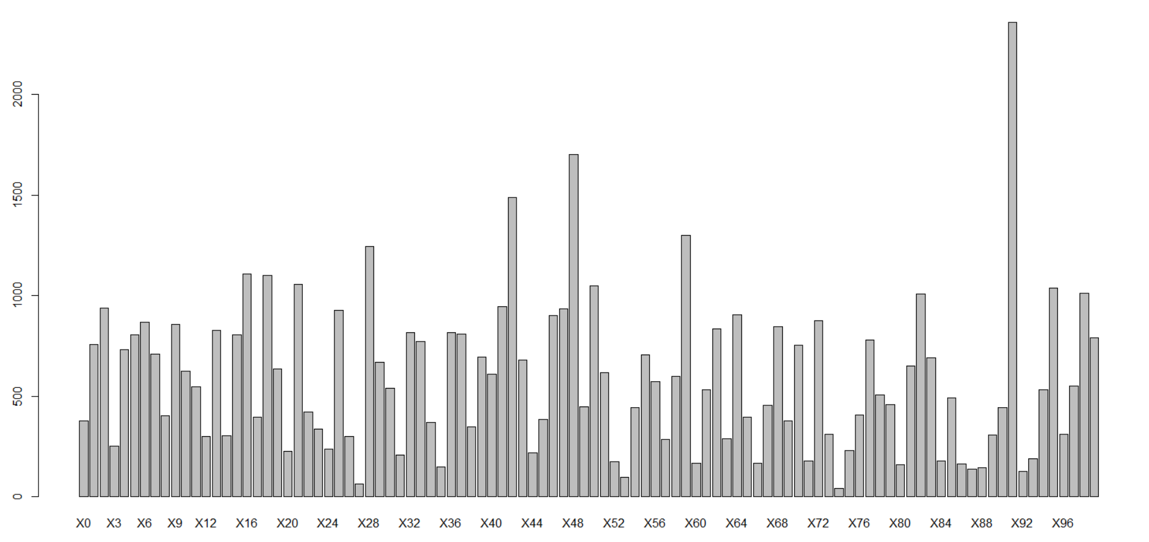

1. Looking at most popular hotel_cluster by looking at % of times that it was booked

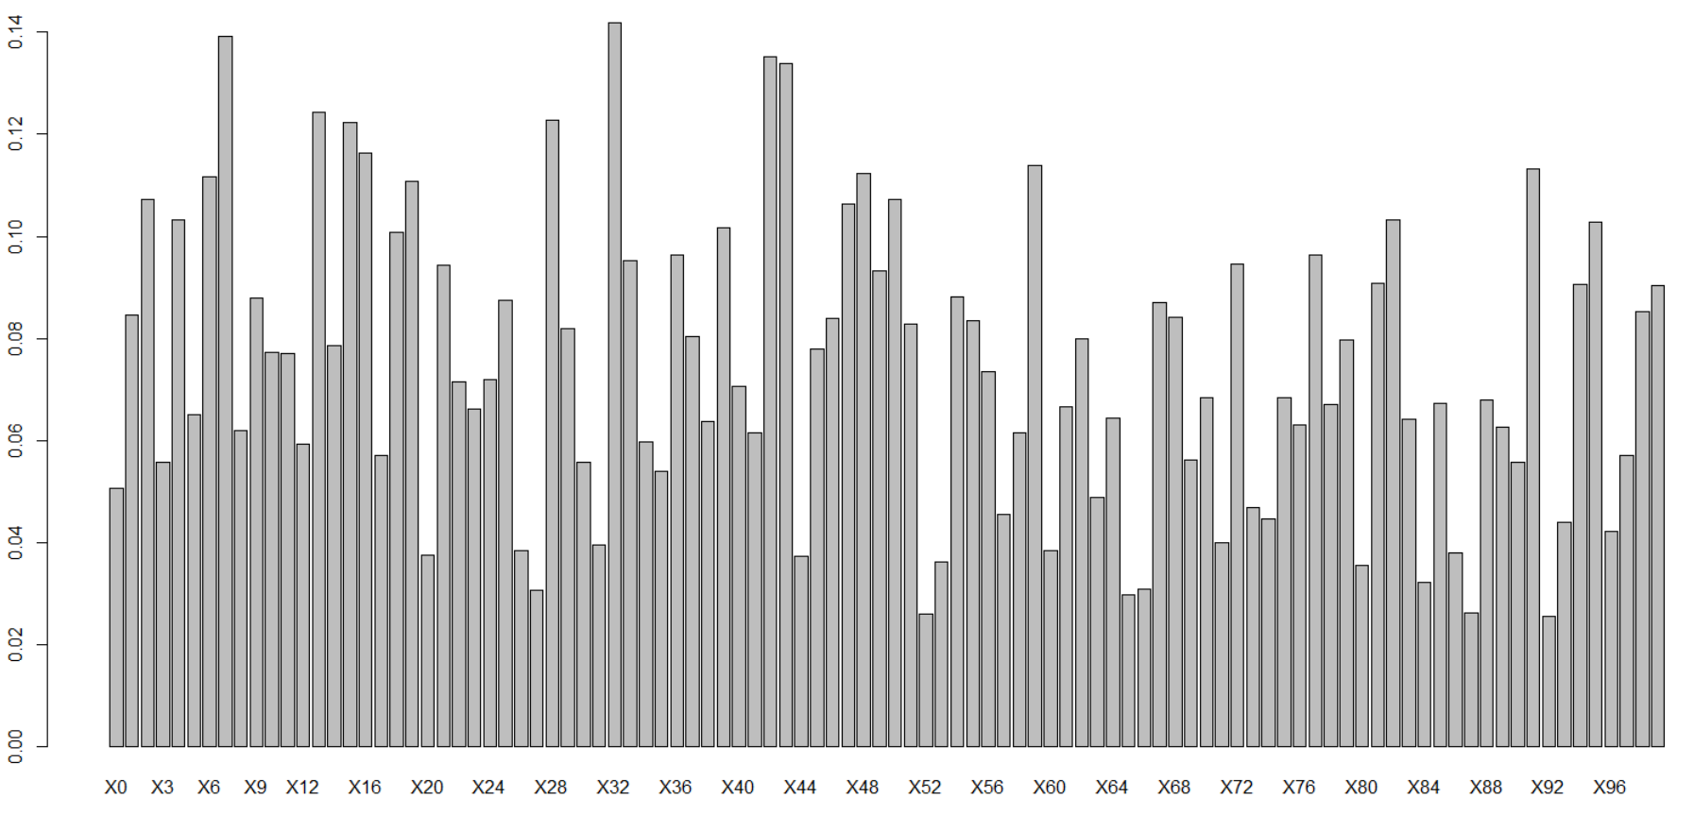

1. Determinig the percentage of click and booking rate

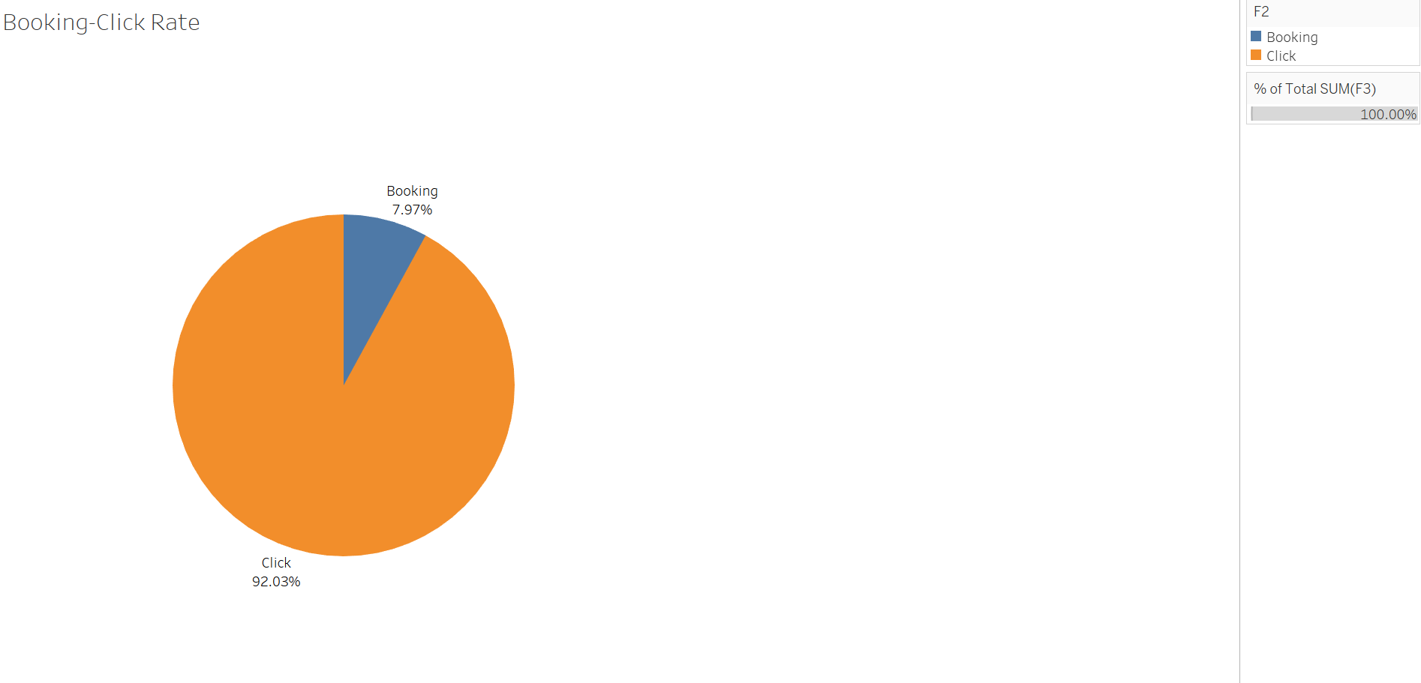

1. Generate the number of times a hotel_cluster has appeared per destination

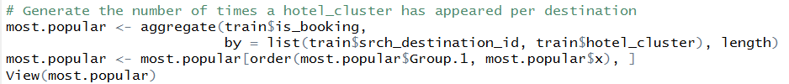

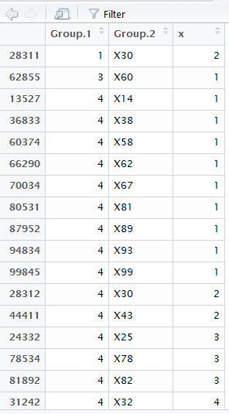

Code for the Data Visualization

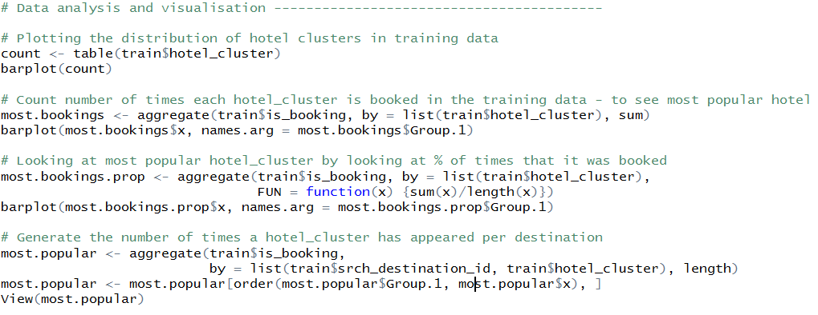

APPROACH

Sentiment Analysis

Our aim is to apply machine learning to predict a hotel review score based on the hotel review given by customer.

What is Sentiment Analysis?

Sentiment Analysis is the process of determining whether the statements are written in a positive, negative or neutral way. It tries to predict the opinion of the user.

Most of the sentiment analysis tries to extract words and classify them as positive, negative or neutral. Based on the score of each words, the score is aggregated and the total sentiment is predicted based on the score. The issue with this approach is that, that it does not take into consideration the order in which the words occur and also in what sense the word was being used. This results in loss of information.

To overcome the issue where we try to use the sense in which word is used in the sentence, we use **Stanford NLP Sentiment Analysis**. The deep learning model used by Stanford NLP builds the representation of whole sentence based on the sentence structure. It computes the sentiment based on how words compose the meaning of longer phrase. The underlying technology used is Recursive Neural Network that builds on top of the grammatical structures.

Below is the breakdown of the sentence in the Recursive Neural Tensor Network:

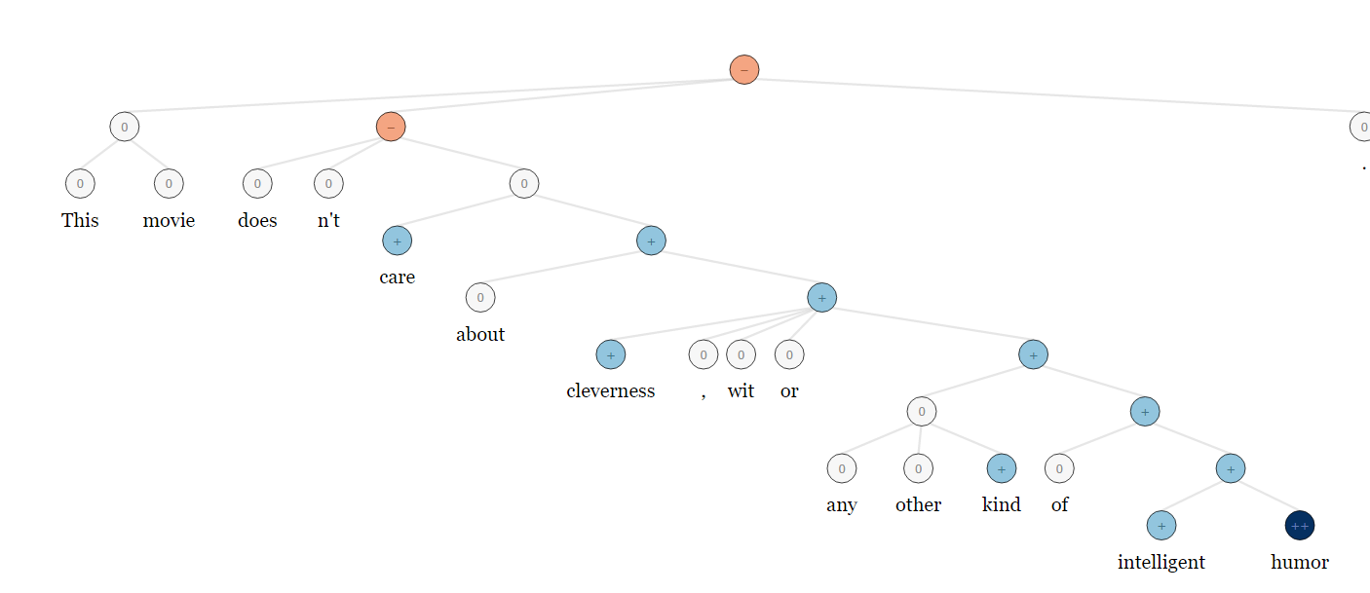

Steps followed to perform the sentiment analysis

1. Read the csv file containing the Hotel Id’s

Code Screenshot : 

Input Screenshot :

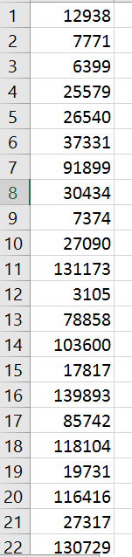

1. Reading the CSV file to get the Hotel Id and passing it with the API key to get the data from Expedia API call

Code Screenshot : 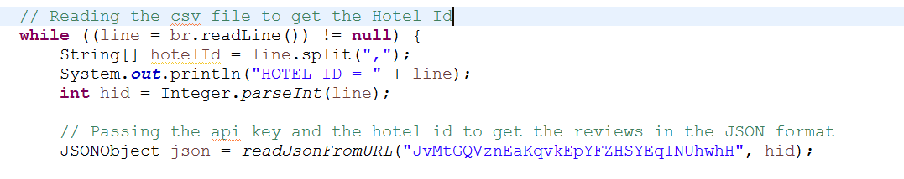

1. Making an API call

Code Screenshot: 

1. The response will be appended into the String Builder

Code Screenshot: 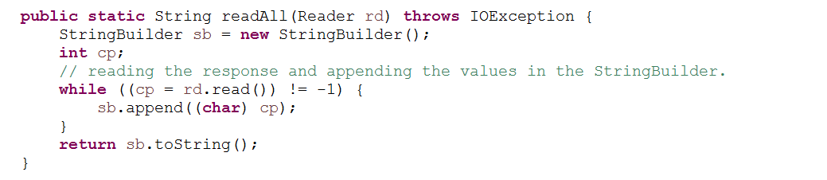

1. Converting the String into the JSON format.

Code Screenshot: 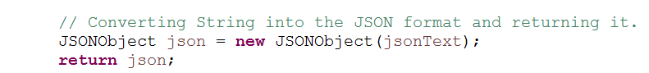

1. Parsing through the JSON and getting appropiate values required for performing the Sentiment Analysis.

Code Screenshot: 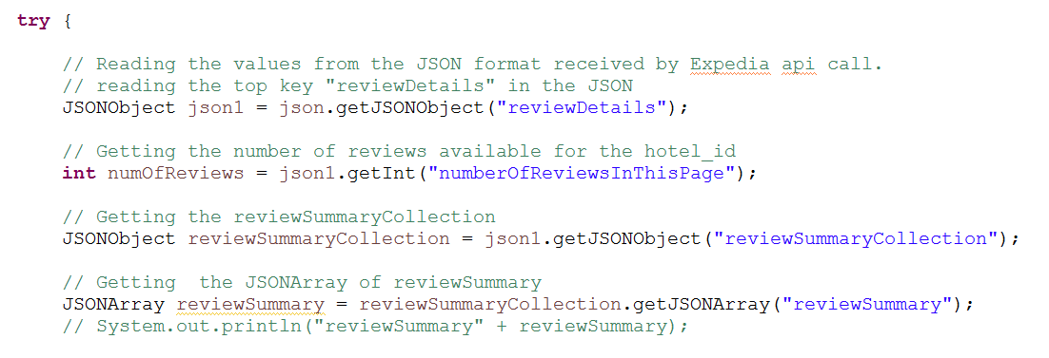

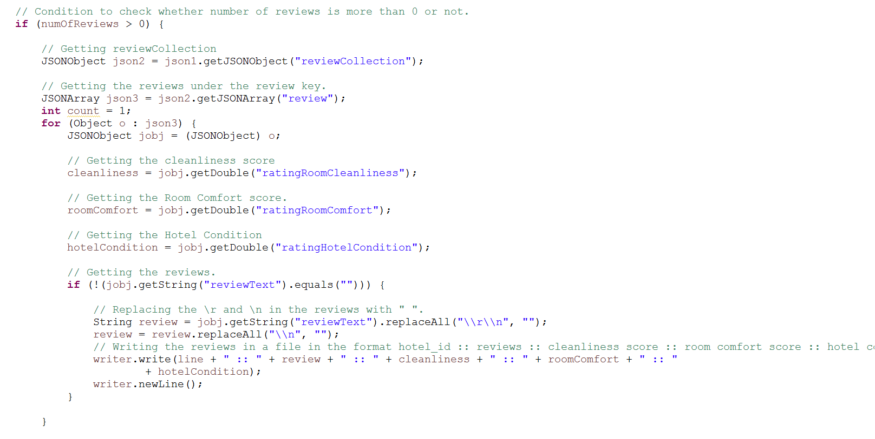

1. The output after parsing through the JSON and writing it to file which will act as the input for the Map Reduce job to perform Sentiment Analysis.

Code Screenshot: 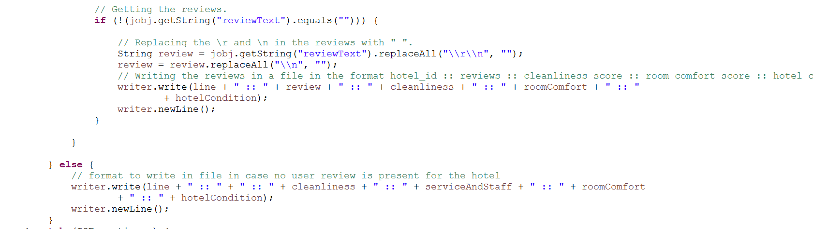

Output File: Format “Hotel Id :: Review :: Cleanliness :: RoomComfort :: HotelCondition”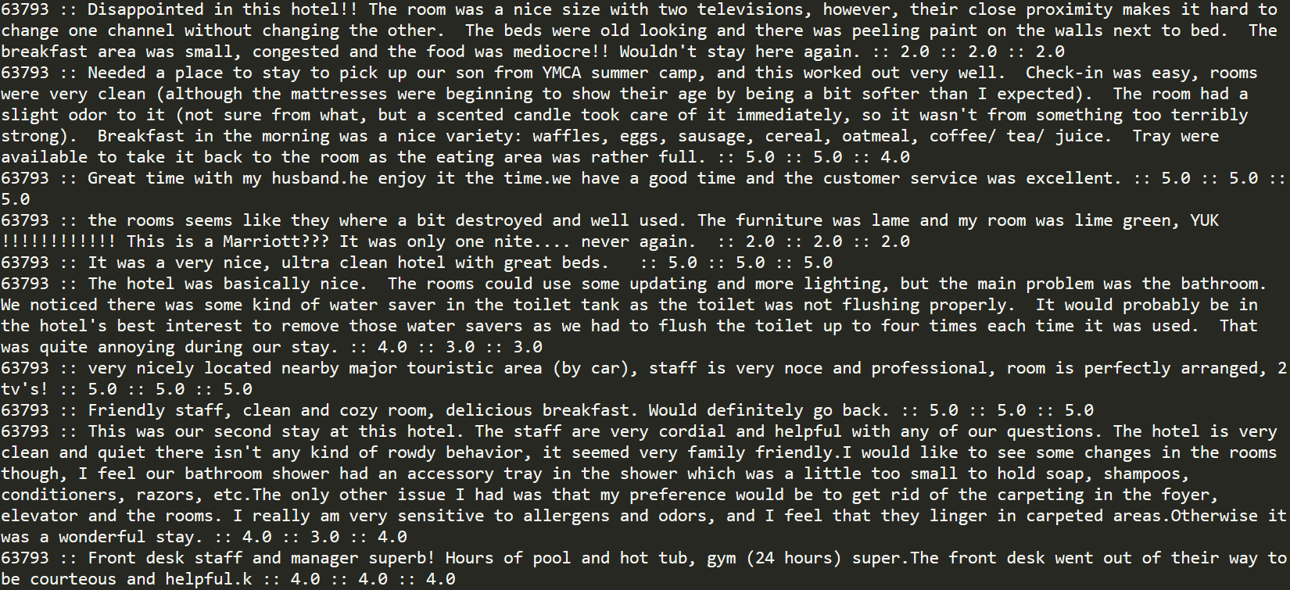

1. After getting the reviews from the Expedia API call, we made a Map Reduce job to get the review score of each reviews over Amazon EC2 instance.

Instance Running Screenshot: 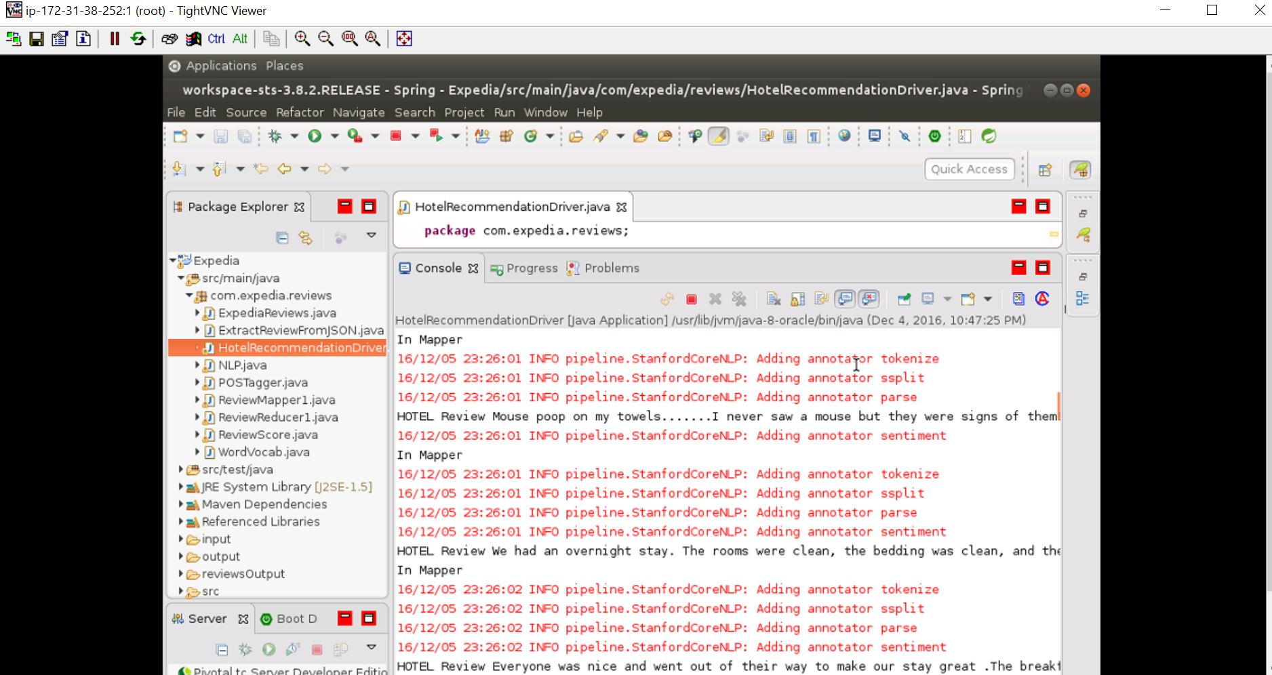

1. HotelRecommendationDriver to start the MapReduce

Code Screenshot: 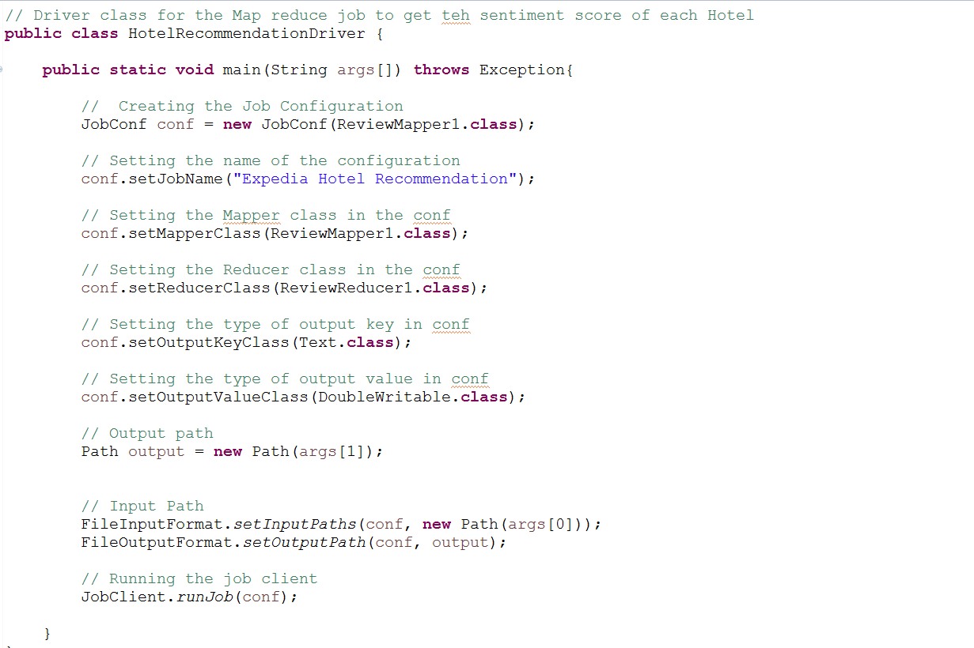

1. The Mapper job reads the line and split the line by “::”

Code Screenshot: 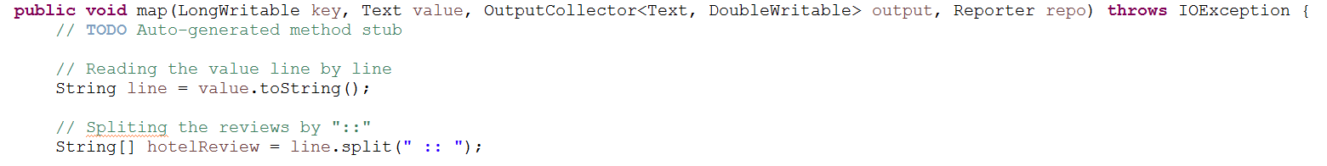

1. Assigning the default value 3 which gives neutral rating if there are no reviews by the user.

Code Screenshot: 

1. Calling the NLP initialization, which adds Sentiment to the Annotators list for analysing the text. Tokenizer saves the character offset of each token in input text, split the sentence into tokens, Parse provides full syntactic analysis.

Code Screenshot: 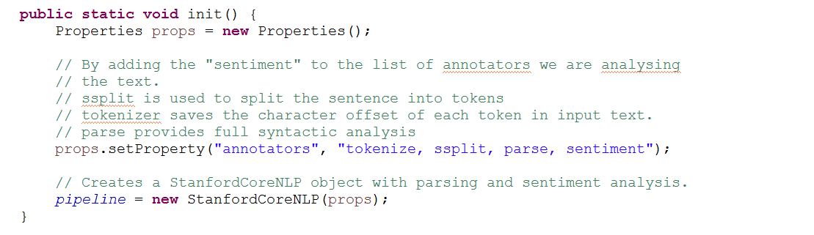

1. If there is no hotel review, we assign the review score as 3 which gives the Hotel neutral review. Code Screenshot: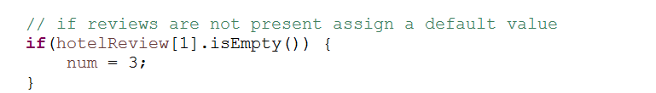
2. If there is a review we call the NLP sentiment to calculate the review score.

Code Screenshot: 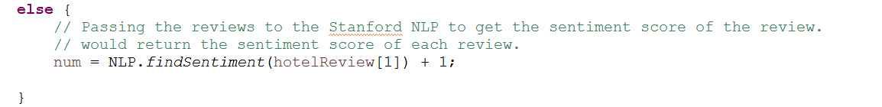

1. The review is then passed to NLP findSentiment which forms the Sentiment Analysis Tree by forming the Recursive Neural Network. This way the model understands the meaning of each word in a sentence and how the word is used in the sentence. The output of this would be the sentiment score of the review.

Code Screenshot: 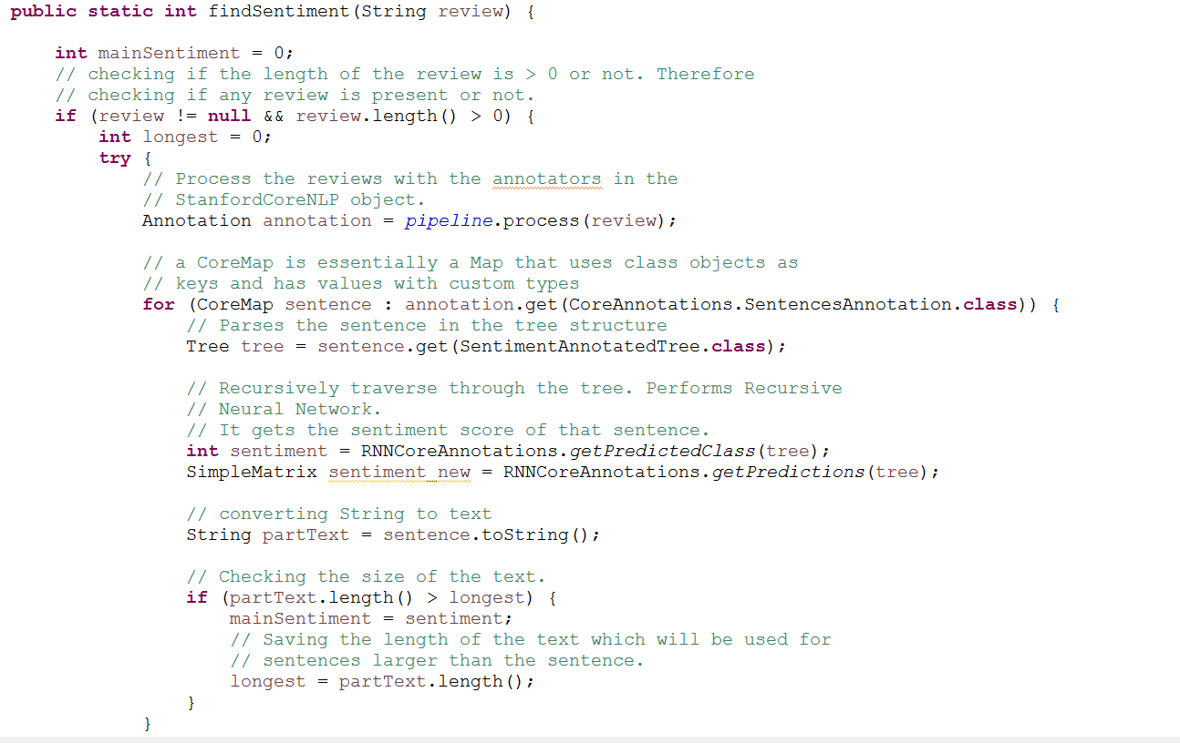

1. We extract the score of “Cleanliness”, “RoomComfort” and “Condition Score”

Code Screenshot: 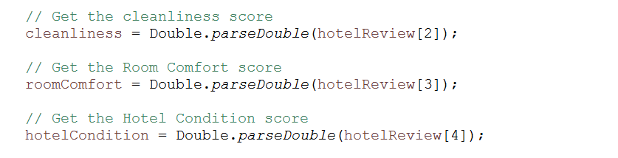

1. We take all the values and average it out.

Code Screenshot: 

1. The output of the mapper, would be “Hotel Id” and score each review corresponding to the “Hotel Id”

Code Screenshot: 

1. The intermediate value would be the “Hotel ID”/<List of review scores corresponding to hotel id>
2. The intermediate key/list of values would be passed to the reducer. The reducer would sum up the intermediate values.

Code Screenshot: 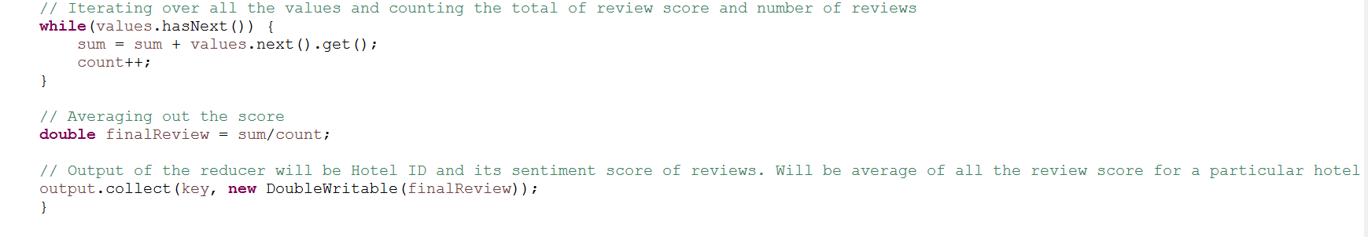

1. The final output after the reducer completes its run would be “Hotel_Id and final Review Score”

Code Screenshot: 

File Screenshot: 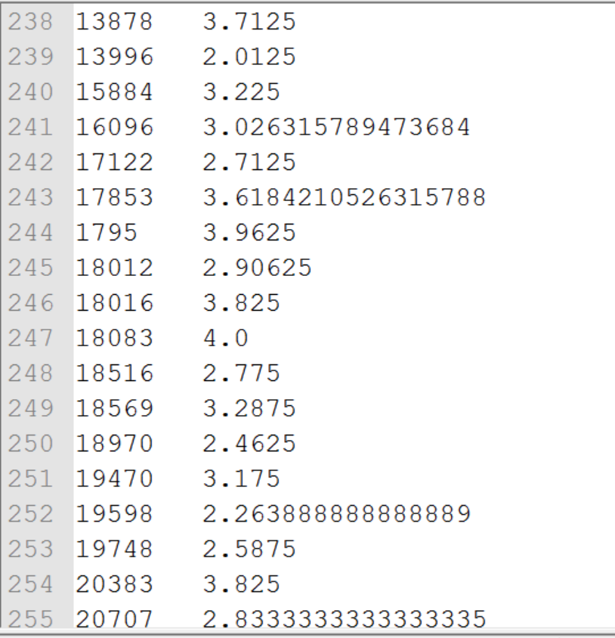

**The meaning of review score :**

**1 = Very Negative**

**2 = Negative**

**3 = Neutral**

**4 = Positive**

**5 = Very Positive**

MACHINE LEARNING

Once we compute the review score using the sentiment analysis, we are going to use that as one of the feature while training the model.

Predicting the ranking of the search result

After cleaning the data, we need to train the model, since the data is of 3.2 GB, training the data will take approximately 2-3 hours and therefore we are going to store the model and later when required we can just load the model and do the prediction. The stored model names are:

1. XGBoost_click_bool
2. XGBoost_booking_bool
3. XGBoost_position

We are going to use XGBoost model for this prediction, XGBoost is short for “**Extreme Gradient Boosting**”. XGBoost is an optimized distributed gradient boosting system designed to be highly efficient, flexible and portable. It implements machine learning algorithms under the Gradient Boosting framework. XGBoost provides a parallel tree boosting(also known as GBDT, GBM) that solve many data science problems in a fast and accurate way. The same code runs on major distributed environment(Hadoop, SGE, MPI) and can solve problems beyond billions of examples.

Clean File Screenshot

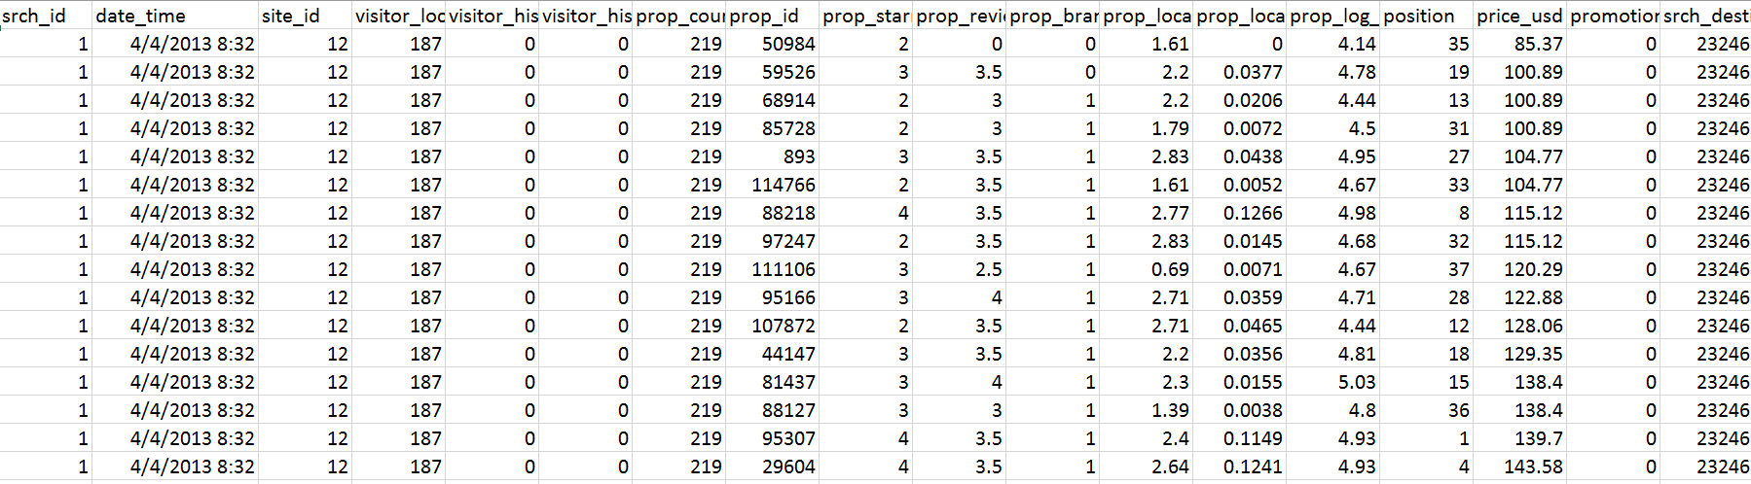

* **R Script**

Initially we are going to set the working directory for the personalized searching ranking input file i.e., train/test.csv to clean it. After that we are going to install the libraries like 'xgboost', 'caret', 'ggplot2', 'plyr', 'dplyr', 'gbm'. XGboost is the prediction algorithm which is used for ranking the prediction. After installing we load the libraries.

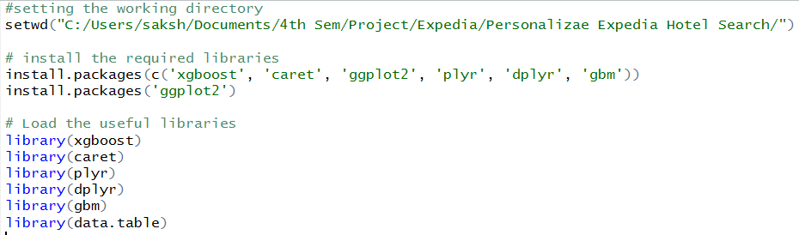

Read the cleaned training and testing data



Setting the seed and fetching the unique search ids from the train data

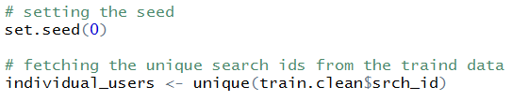

Generate random samples for a training and a testing sets



Getting the length of the unique records or users from the selected data



Create the sample of the data based on search id and sample.train and after doing this remove the not required variables which are not required

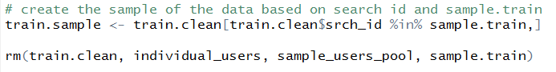

We are going to predict the click_bool first, then we are going to use the predicted value and other variables to predict the booking _bool and similarly we are going to predict the **POSITION.** But before that we need to select the attributes based on which we are going to do the prediction. We are using **selected_features.txt** for reading the features names.



**Selected Features.txt**

This file consists of features like

1. Expedia Info - site_id
2. Hotel Attributes - country, rating, review score, brand
3. Search Query – destination id, adult or child count, length
4. Feature Engineer attributes – aggregate score, delta price, price order and target month

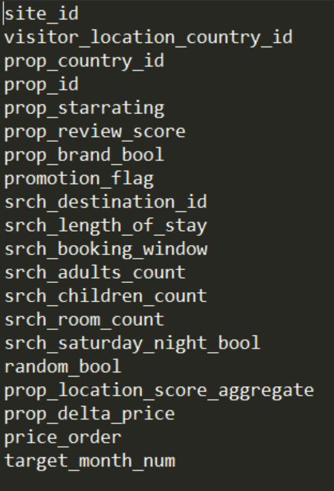

1. **Model for click_bool prediction**

We are going to use the variables selected form the text file, we are going to convert the data into **xgd.matrix** and convert every column to numeric. XGBoost has parameters objective is **binary:logistic**, binary because click can be either 0 and 1, thread is 6 and depth of training is 40.

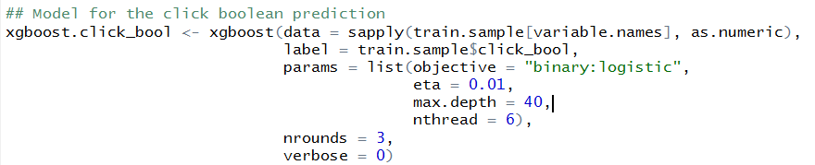

Now we are using the predict function to predict the clicking value, since we are using logistic regression, there will be a numeri value we have to decide the threshold, in our case it is 0.489 which is the mean from the train data and then we are going to append the same to the train data

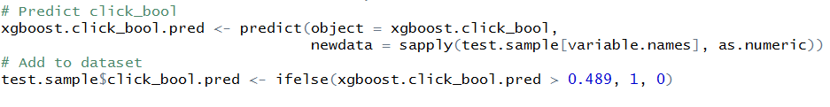

1. **Model for booking_bool prediction**

We are going to use the variables selected form the text file and booking_bool, we are going to convert the data into **xgd.matrix** and convert every column to numeric. XGBoost has parameters objective is **binary:logistic**, binary because click can be either 0 and 1, thread is 6 and depth of training is 40.

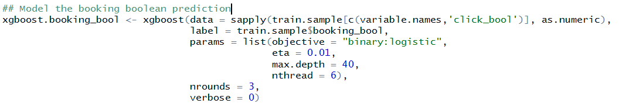

Now we are using the predict function to predict the booking value, since we are using logistic regression, there will be a numeri value we have to decide the threshold, in our case it is 0.5 which is the mean from the train data and then we are going to append the same to the train data.

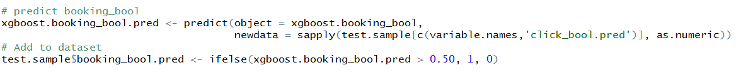

1. **Model for position prediction**

We are going to use the variables selected form the text file, click_bool and booking_bool, we are going to convert the data into **xgd.matrix** and convert every column to numeric. XGBoost has parameters objective is **rank:pairwise**, thread is 6 and depth of training is 40 and we have to provide **evalution matrix ndcg@05 (Normal Discounted cumulative gain (DCG) is a measure of ranking quality.**

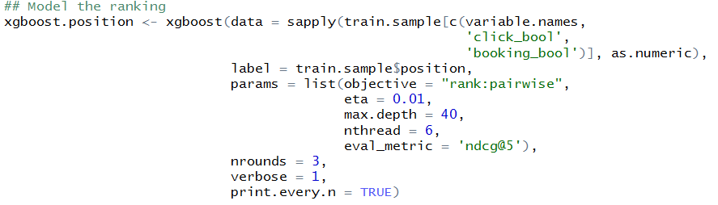

Predict the position in the ranking

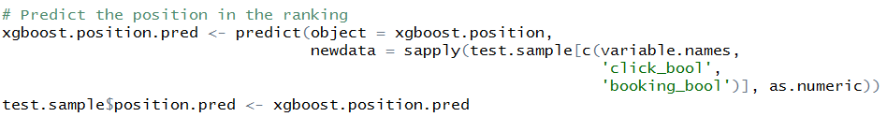

Order the ranking based on the search id and we can output the same to the csv file.

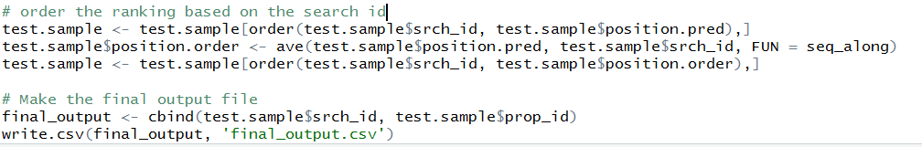

* **Expose as web service**

After training the model, we have saved them as **xgboost_click_bool, xgboost_booking_bool and xgboost_position.** Now we are going to upload the same as a zip to the Microsoft Azure. There we are going to provide the test.csv as a input we are going to get the order of the hotel ids or we can say we will get the ranking of the hotel ids.

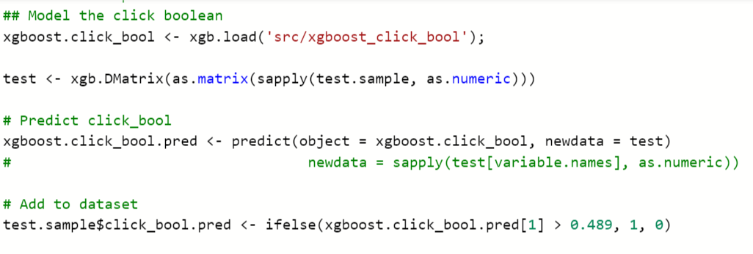

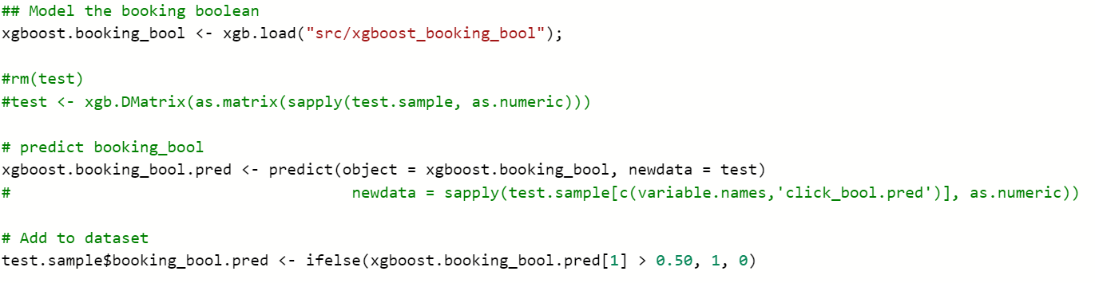

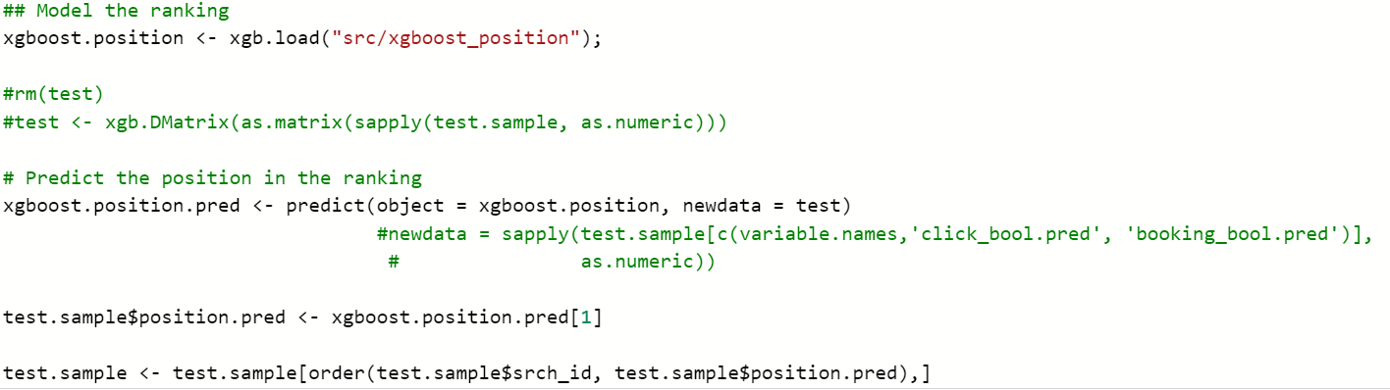

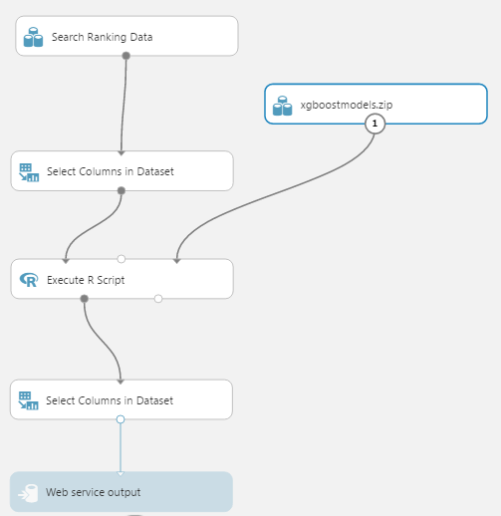

In the above model, select column in Dataset is used for selected the column i.e., the selected features which we discuss earlier. Screenshots ofn Execute R script is shown above, which are basically fetching the model from zip and using it for prediction and adding the predicted column to the dataset. Web Service output is going to show the output.

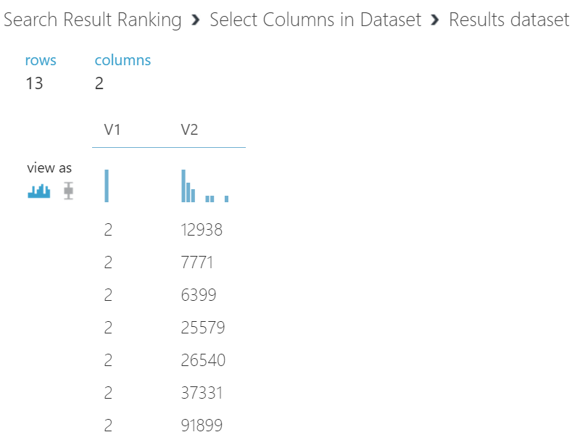

The above is the output, V2 is the hotel ids based on particular search which is value as 2 in this case.

Predicting the Cluster

We are using **Mutliclass Classification: Random Forest, Decision Jungle and Neural Network,** later we are going to compare the results and expose the best model to the UI.

First, we are selected the attribute from the dataset, we are not going to use all the attributes, the selected attributes are **distance of destination from the user country, destination ID, hotel market, location attractiveness of hotel, hotel characteristics, user aggregated purchase history and expedia site id.** Once we select the attributes, we can use **Partition and Sample** to split the data into 80% and 20%. Later using Train Model and algorithm we can train the model, after that we can use score model and evaluate model to calculate the performance metric and confusion metrix.

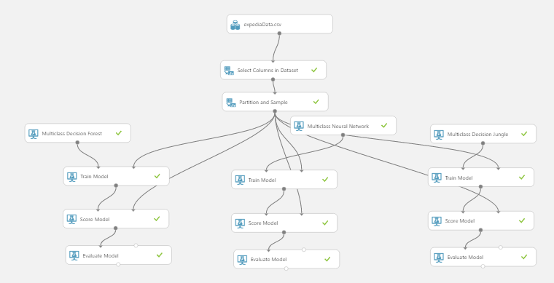

**Random Forest**

**Performance Metric**

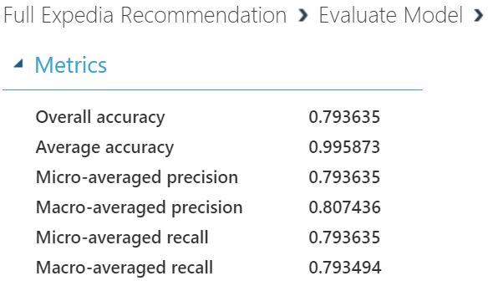

**Confusion Metric**

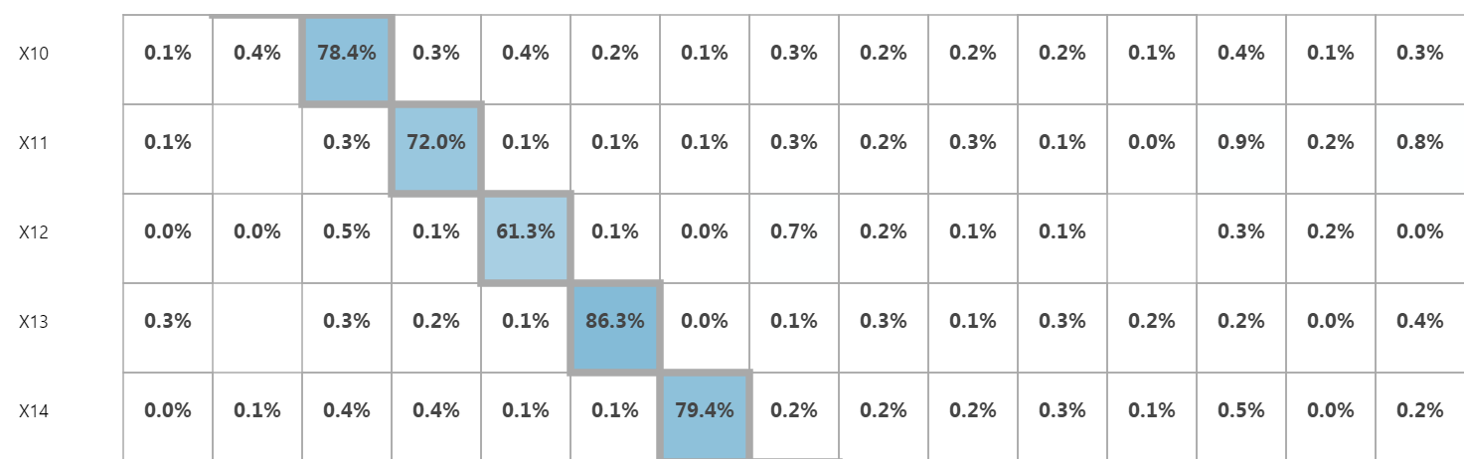

**Decision Jungle**

**Performance Metric**

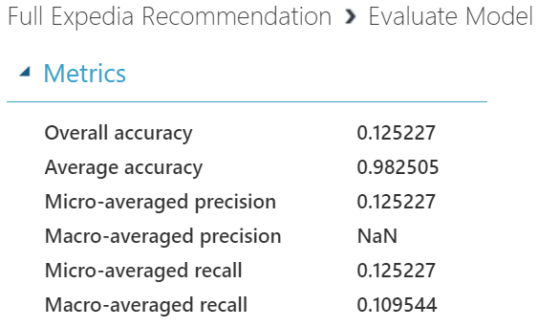

**Confusion Metric**

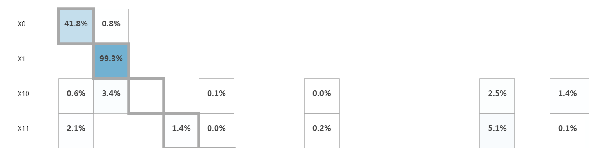

**Neural Network**

**Performance Metric**

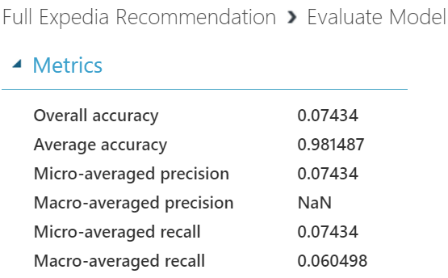

**Confusion Metric**

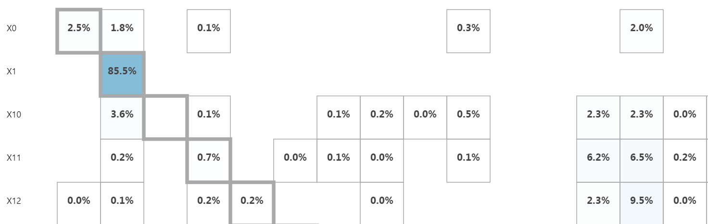

After observing the performance metrics and confusion metrics of all the three algorithms, we decide to opt for Random Forest which gives us the accuracy of 80%

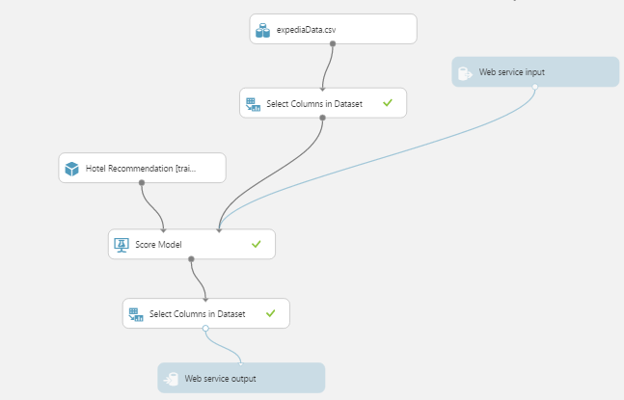

Web service input and output are used for getting the inputs for the web service and output will give the cluster which is recommended to user.

Comparison of Azure ML with Spark Mlib

Apcahe Spark MLlib is Spark’s scalable machine learning library consisting of common learning algorithms and utilities, including classification, regression, clustering, collaborative filtering, dimensionality reduction. For our purposes, we are running **Random Forest** and **Logistic Regression** for multiclass classification. Since we have to predict the hotel group in which user is likely to book the next booking for his/her travel.

* **Changing the data from csv to libsvm**

Apache Spark accepts the different file format i.e., **libsvm format**, than the csv and our data is in the csv, so for converting the data from csv to libsvm we whave R script which help us do that.

* **R script Code**

Initially we are going to set the working directory for the spark file to be generated. After that we are going to install the libraries like e1071, SparseM (it provide basic linear algebra functionality for sparse matrices. After installing we load the libraries.

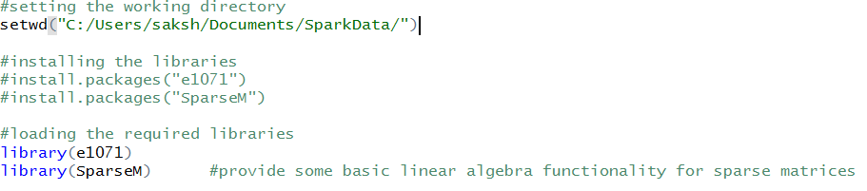

Once we are done with the initial setup, we can move to computation, now we are going to read the expediaData.csv (it is cleaned file which was generated after reading the train.csv provided by Kaggle). After this we are going to convert the labels i.e., predicted column into the numeric format and it is going to be the first column in our new file. Our csv still has orig_destination_distance containing NA, this is distance from user location to destination he is looking for, if is too large or we are unable to compute they have given as NA. We are replacing the NA with mean of the column, this is the basic technique for handling missing data.

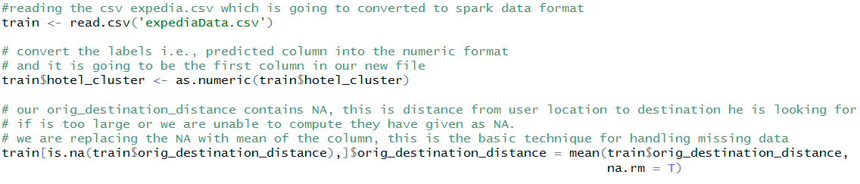

Now, we are converting our training data from data frame to matrix. We are converting every column apart from label and going to put the labels in a separate vector so that we can append it later. After getting the data in the matrix format, we are going to use the SparseM library and function **as.matix.csr**  to convert the matrix to sparse row format (this is the format which exclude the column which has zeros and which lead to converting the matrix to sparse matrix. Once we have sparse matrix, we are going to append the same with the labels and get our required libsvm format data.

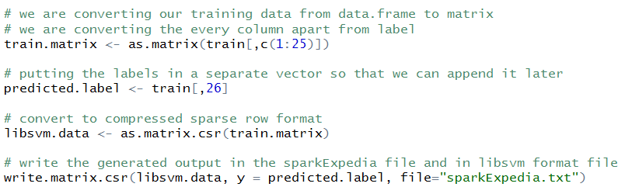

Once the R script is executed successfully, we will get the required output file as **Label (which needs to be predicted) space and column number : column value.**

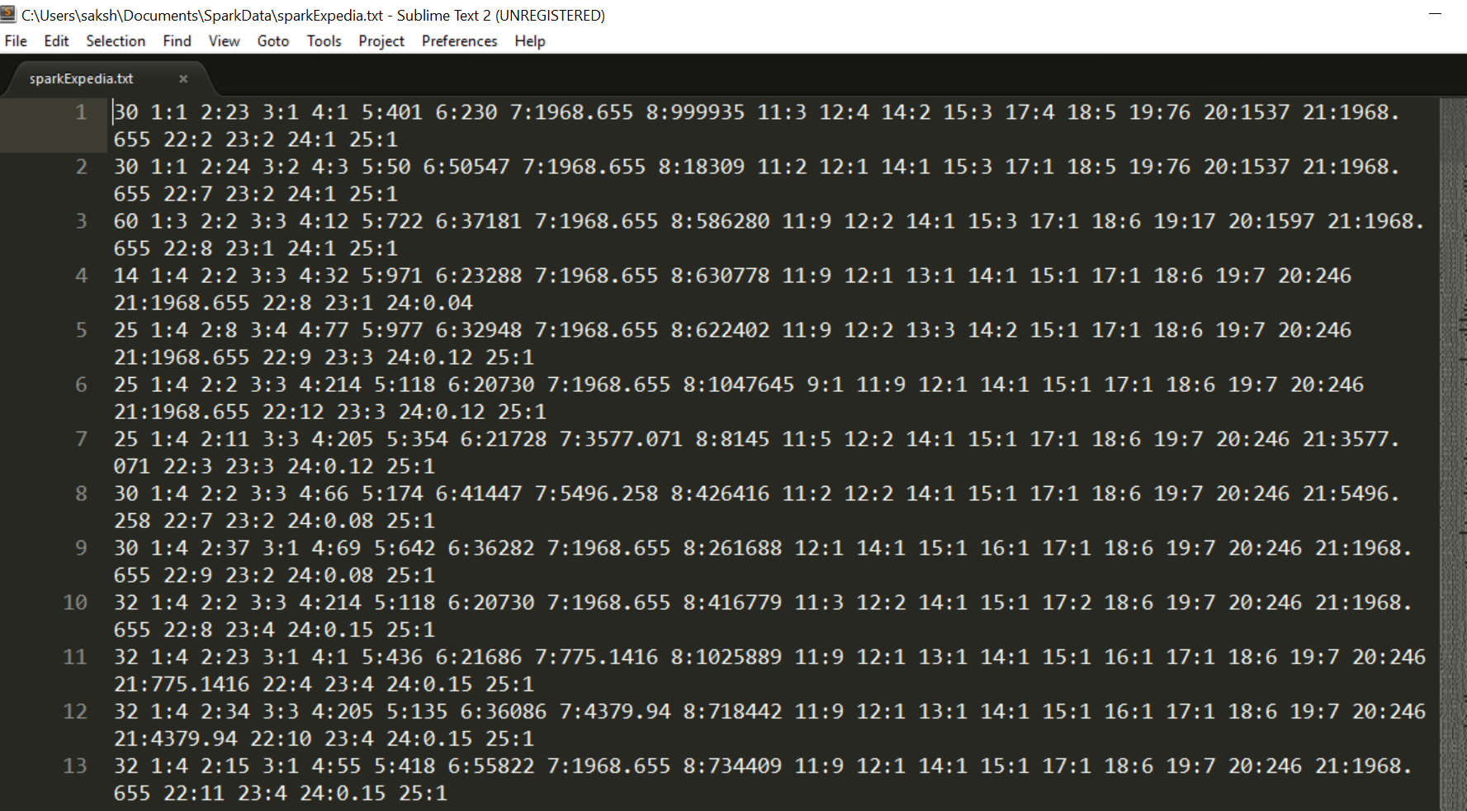

The above file is in the libsvm data format.

1. ***Multiclass Classification: Random Forest***

**Code Explanation**

Setting the working directory for the



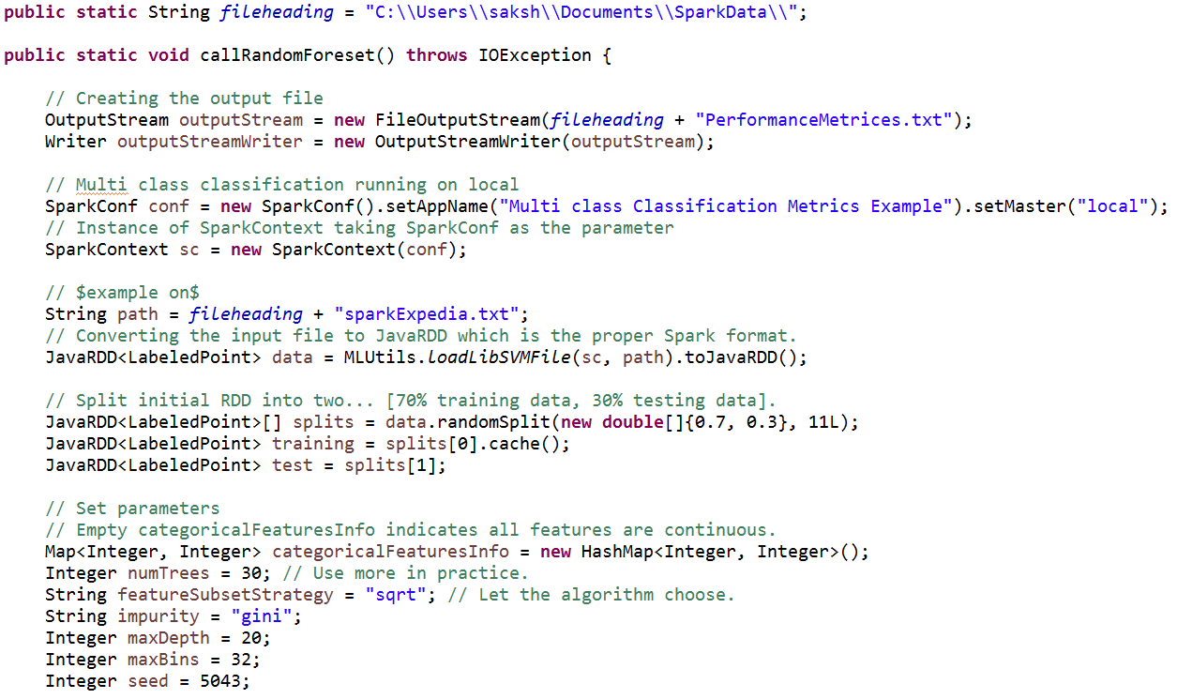

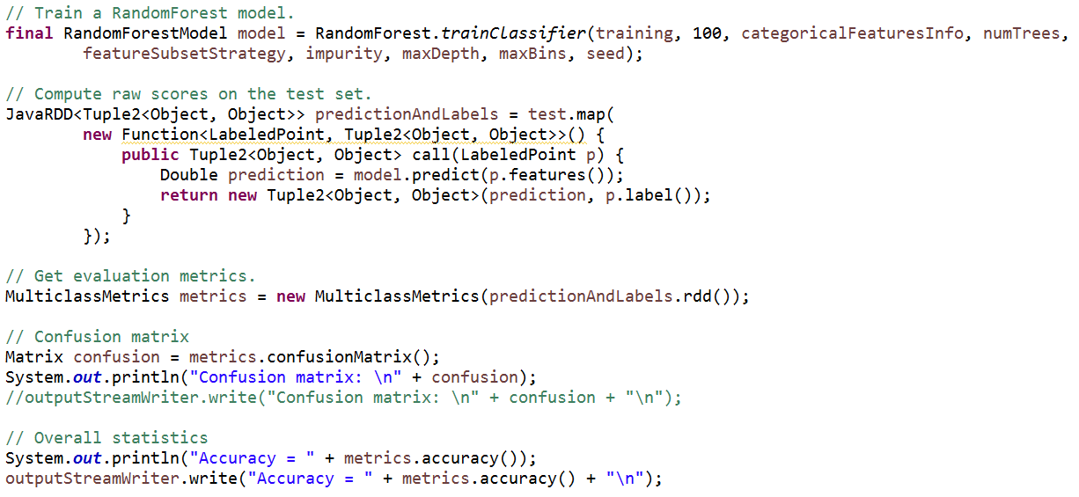

**Accuracy**

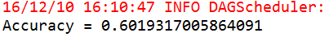

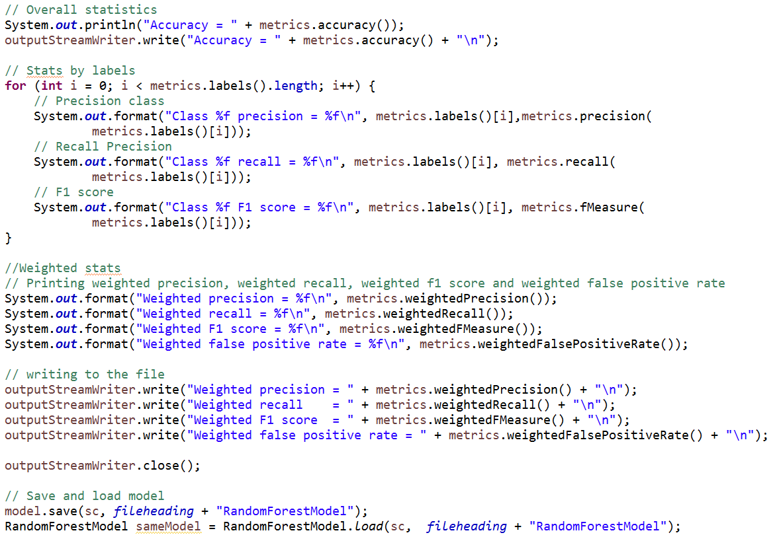

**Statistics by label**

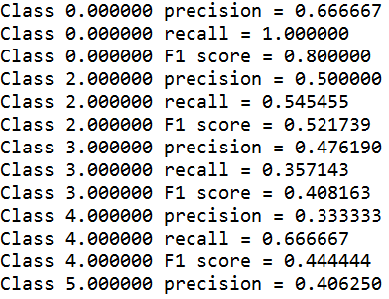

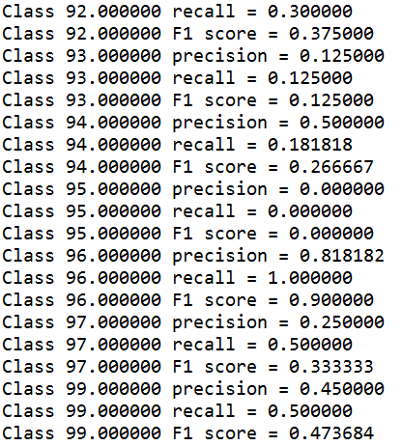

**Weighted Statistics**

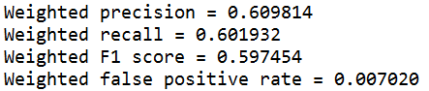

**Confusion Matrix**

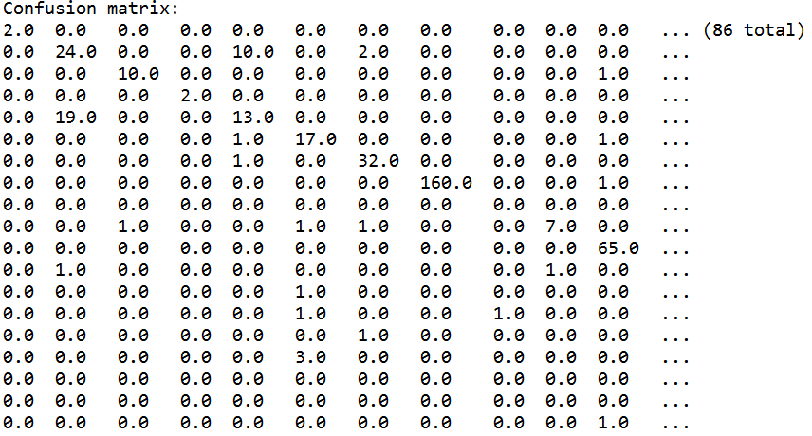

1. ***Multiclass Classification: Logistic Regression***

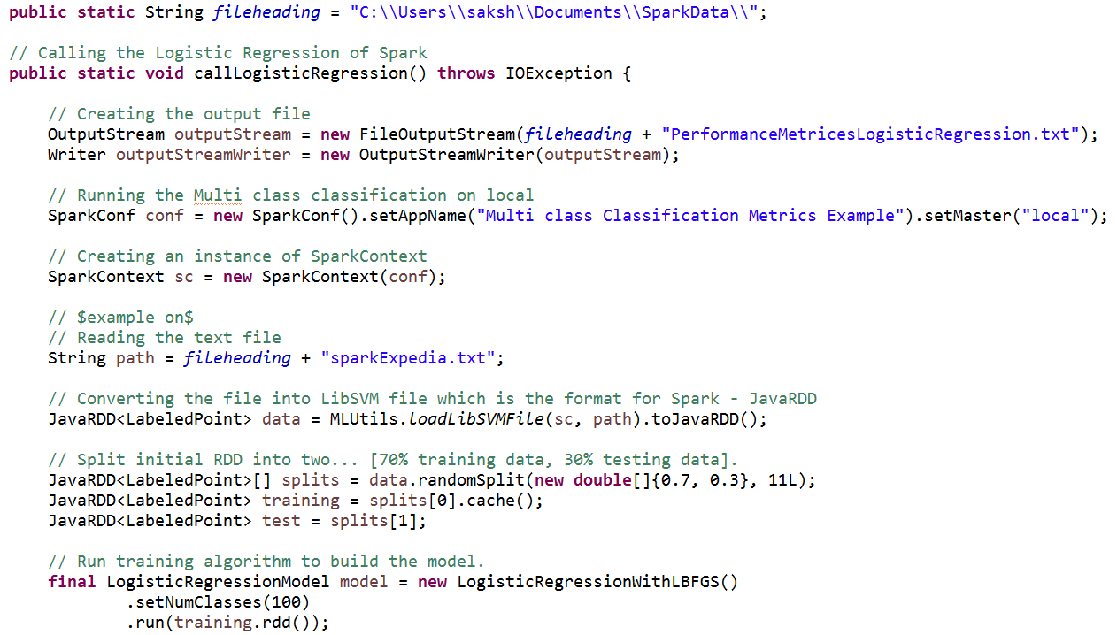

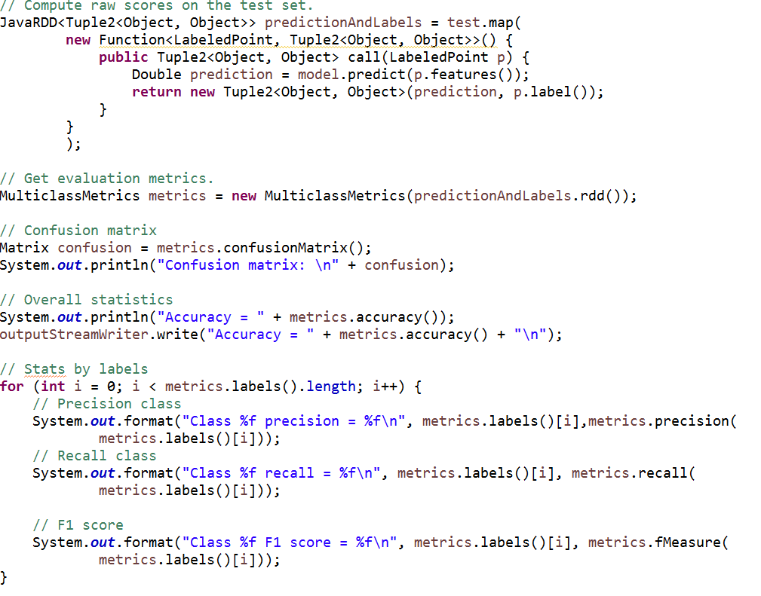

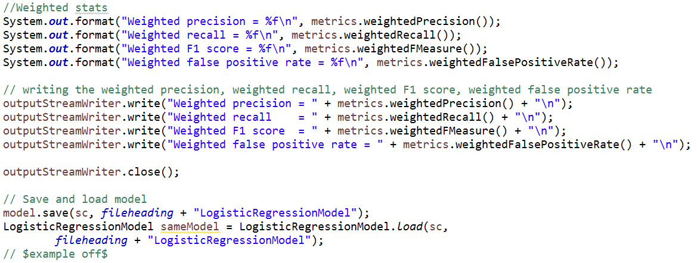

**Accuracy**

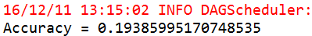

**Statistics by label**

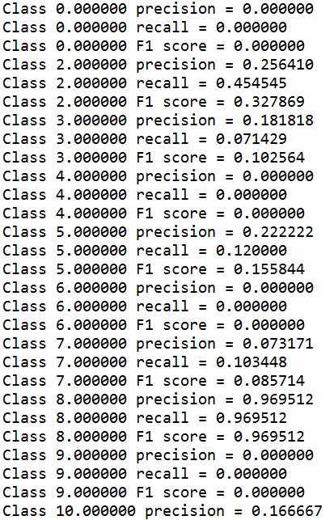

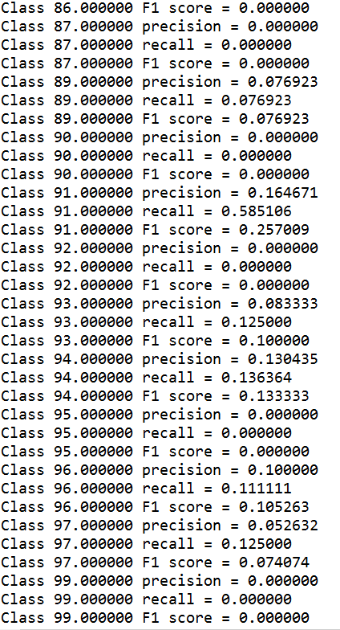

**Confusion Matrix**

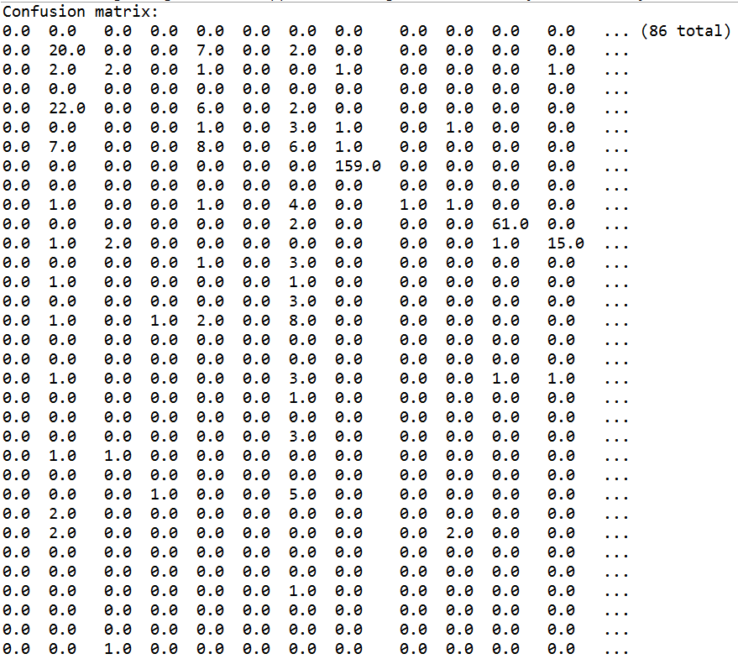

**Weighted Statistics**

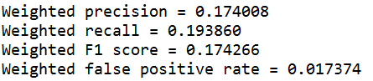

As we can see the accuracy of random forest on Azure ML is 80% and random forest on Spark Mlib is 60%. Therefore, we are going to expose Azure ML random forest as a web service.

APACHE KAFKA

We are using Apache Kafka for live streaming, we are getting the reviews from the real time and then updating the rating so that the next time when prediction is happing it should happen on real time data.

Kafka – a distributed streaming platform

This technology is best suited for a scenario where data has to be published or subscribed to. It is more of a similar to message queue or enterprise messaging system. Can be consumed appropriately into two broad type of applications:

1. Building real time streaming data pipelines between several interfaces and or applications
2. Building real time services to perform analysis or data transformation before exchanging between consumers.

Three major aspects of kafka are: Producer, Consumer and the cluster itself.

Kafka Producer:

The entity under kafka world which is essential to generate or source all the data or messages to be floated over.

Kafka Consumer:

The individual entity which is responsible to ping kafka cluster on time interval basis to look for any new messages or data. The segregation happens on the basis of one concept called ‘Topic’ used extensively by producer and consumers.

At the core of apache kafka is the cluster. This cluster can run in two different modes namely: standalone, distributed.

Producer Producer Producer

Kafka Cluster

Consumer Consumer Consumer

Idea:

Considering the image of expedia among the masses. There is a huge possibility that users will be submitting the reviews or user ratings of their experience with one particular hotel or their stay. At the same time if there is a user who has been booking the same hotel or place, then it is necessary that the visiting user should know about people’s experience with the hotel they are booking.

For this very reason, we have implemented this idea of uploading or producing the reviews on real-time basis which gets uploaded onto kafka producer with its timestamp, hotel id and user review. Now, we need to consume this review, apply sentiment analysis on this review and get the score of this review to better understand whether the experience was positive or negative. We use Stanford NLP to calculate this score on real-time basis and update the already available score of this hotel with necessary aggregation and normalization.

We have utilized kafka’s java api and used the documentation extensively to write the code for designing kafka producer and kafka consumer utility. We have hosted our kafka cluster which comprises of zookeeper server and kafka server on Amazon EC2’s powerful instance.

The concept of topic applies to producer and consumer. We try to segregate the messages or identify them rather based on their origination property. While generating or producing a message, producer assigns a property to that message or data, that property is called topic. We can think of this topic as a #tag concept with twitter.

Process of initiating kafka service:

1. Inititate Zookeepers’ server with specific properties where in we mention the server has to be up on one specific ip address and port. We chose this properties as localhost:2181



Cd kafka_2.11-0.10.1.0



Command to start zookeeper service(keep in mind this has to be in its own instance):

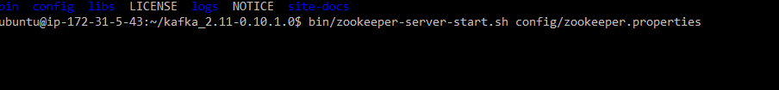

Service started:

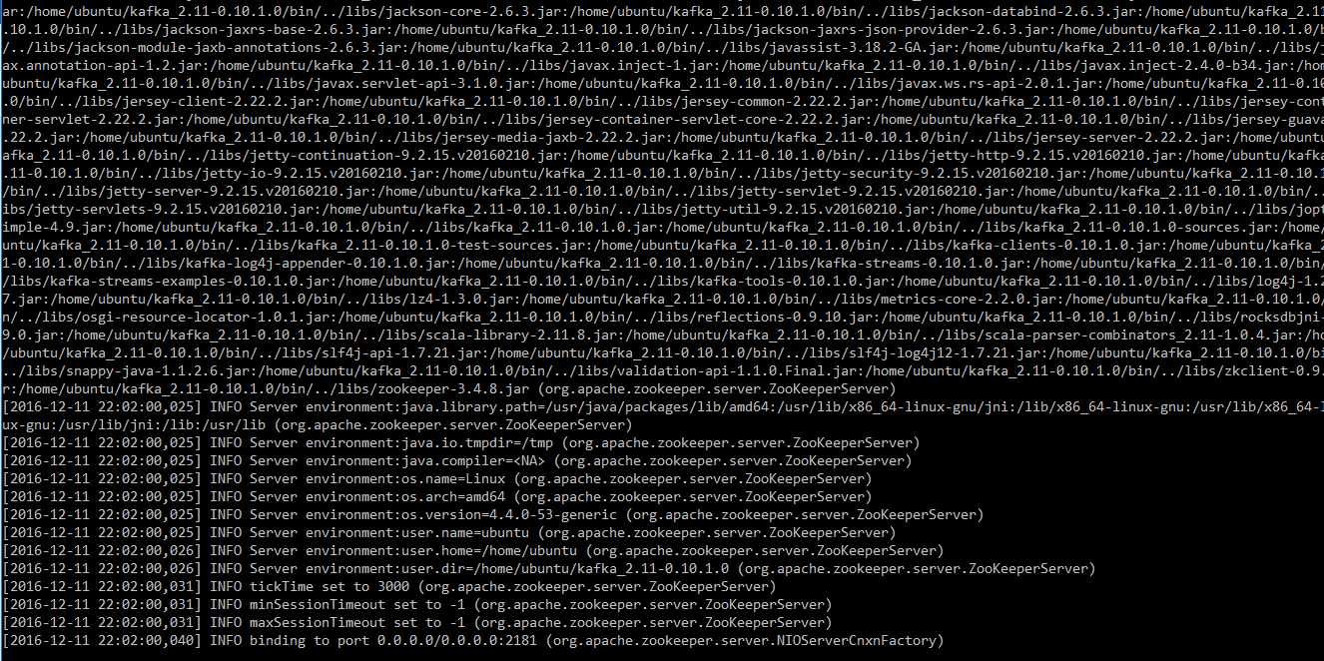

1. Initiate kafka server service:

Command to start kafka service(keep in mind this has to be in its own instance):

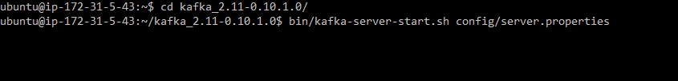

Service started:

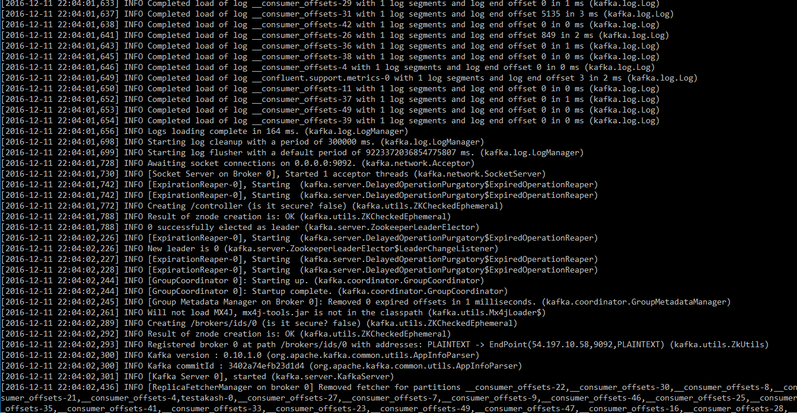

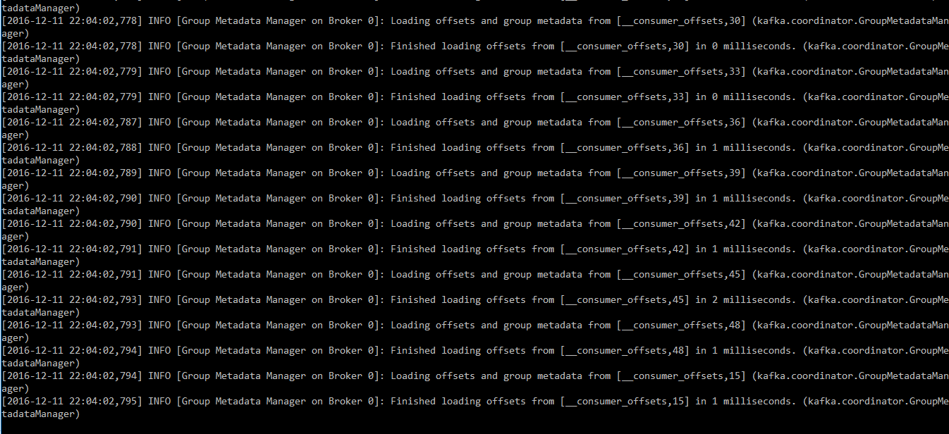

Make sure zookeeper and kafka service is working:

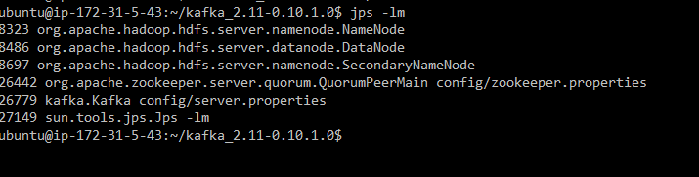

1. Create topic to be used as a common attribute between producer and consumer



1. Check if your topic has been created by listing all the topics available with kafka right now

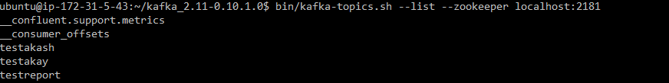

1. We can utilize producer and consumer to exchange messages on real-time basis.

Producer – to test whether producer and consumer are in sync and send over some messages:

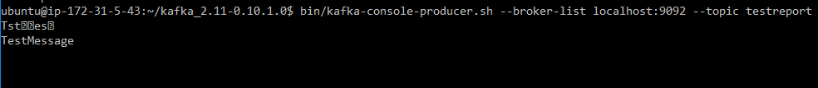

1. Consumer – to check if messages sent by producer are same received here: 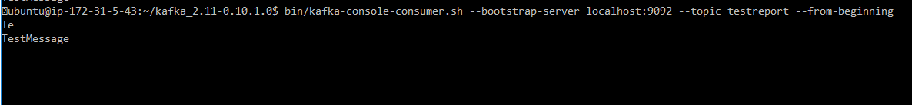

After completing these 6 steps, we are assured that kafka and zookeeper service are running properly.

Project Implementation:

KafkaProducer-

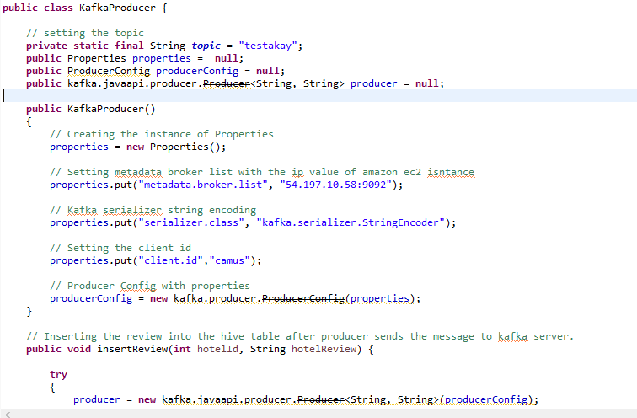

Properties a utility function provided by java. Used to configure to point to specific ip and port to push messages to.

ProducerConfig a class defined under kafka-core java library which enables kafka to consume the properties java’s utility function and evaluate configuration parameters.

Creating instance of kafka producer utilizing producer configuration instance which has all the configuration parameters loaded.

Functions:

1. InsertReview

This method is to get reviews from user interface and publish the reviews on kafka producer, for consumer to consume it.

1. GeneratePositivieReviews

Because one positive or negative review won’t make much of a difference for user to evaluate the real time feed experience. We have created a method where in at a time 30 positive reviews will be generated for that particular hotel to observe the change in review score and to simulate it to the user.

1. GenerateNegativeReviews

Because one positive or negative review won’t make much of a difference for user to evaluate the real time feed experience. We have created a method where in at a time 30 negative reviews will be generated for that particular hotel to observe the change in review score and to simulate it to the user.

Kafka Consumer Service:

There is a separate utility service working on another machine trying to pull Kafka server continuously to check if there is any new review available for it to consume.

Implementation:

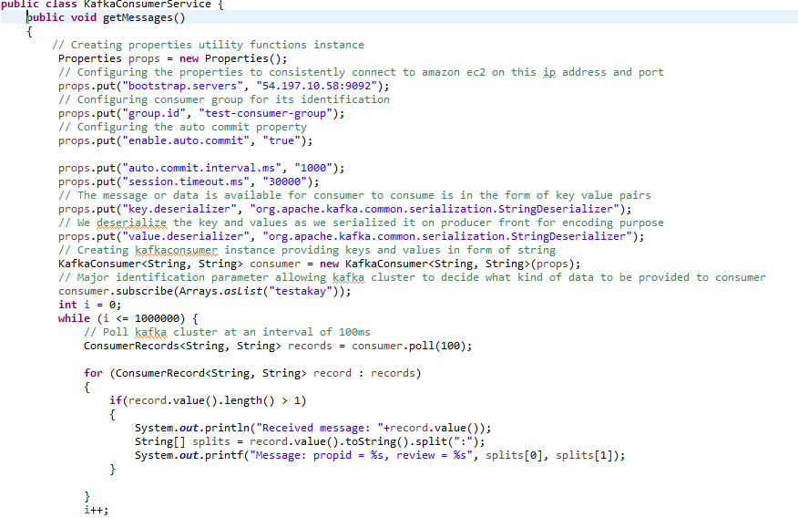

Work by Individual

Hari: WebUI, Back-end java programming, Machine Learning, Apache Hive, Azure Studio

Tarun: WebUI, Back-end java programming, Stanford NLP, Mapreduce Jobs, Apache Hive

Akash: WebUI, Back-end java programming, Apache Hive, Apache Kafka, Data Analysis

Obstacles & Resolution

1. Hive Configuration

There is limited availability of documentation on hive configurations. There are close to 100+ different configurations which should be set properly to enable server-side connection on Hive. Our specific requirement was to have the ability to connect to hive server on Amazon EC2 and retrieve records from a java application running on our laptops

Resolved:

After non-stop research of the support topics and going through emails of developer network. We got the configuration properties in bits and peices. Then we got to know that three services need to be started to consume hive server. Those three services are Metastore, Hiveserver2, Beeline.

2. XGBoost environment issue

XGBoost is developed to work on Linux. Because of limited availability of support in online communities. We got to know this after a lot of research on this. So later we resolved this issue by installing virtual machine on windows platform.

3. Spring 3.1.1 is not compatible with Jackson 2.x

We reolved this by upgrading version of spring mvc to 3.2.5.

Future Scope

1. In our project when we send review data from kafka producer to kafka server. The data has very simple format of just two strings. But we can expand this by having full fledged POJO's and defining schemas under hive and utilizing confluent-3.11 api to define schema-registry on kafka server.
2. We can implement deep neural network algorithms to recommend hotel groups and decide on hotel rankings as well.

Research & findings

We researched spark machine learning libraries and ran several algorithms to understand the accuracy provided by spark. But our project machine learning accuracy was best with Random forest than spark's tools.

Results

There are multiple components bearing separate outputs. Individual component's results have been attached above under each component.

REFERRENCES

<https://spark.apache.org/docs/1.2.0/mllib-ensembles.html#random-forests>

<https://www.kaggle.com/c/expedia-personalized-sort/data>

<https://www.kaggle.com/c/expedia-hotel-recommendations/data>

<http://www.michael-noll.com/tutorials/running-hadoop-on-ubuntu-linux-multi-node-cluster/>

<https://www.ics.uci.edu/~shantas/Install_Spark_on_Windows10.pdf>

<https://github.com/shekhargulati/day20-stanford-sentiment-analysis-demo/blob/master/src/main/java/com/sentiments/analyzers/SentimentAnalyzer.java>

<https://msdn.microsoft.com/en-us/library/azure/dn905952.aspx>

[https://cwiki.apache.org/confluence/display/Hive/GettingStarted](https://www.google.com/url?q=https%3A%2F%2Fcwiki.apache.org%2Fconfluence%2Fdisplay%2FHive%2FGettingStarted&sa=D&sntz=1&usg=AFQjCNEbw-XGcyNmHeVMCpNnUIG3ZXy8ug)

<https://spark.apache.org/docs/latest/ml-classification-regression.html#logistic-regression>

[https://kafka.apache.org/documentation#gettingStarted](https://www.google.com/url?q=https%3A%2F%2Fkafka.apache.org%2Fdocumentation%23gettingStarted&sa=D&sntz=1&usg=AFQjCNENccWPwpsNYdKAciYO1ekIFll_Xw)